Palestinian Labor Migration to Israel since Oslo and Beyond

Leila Farsakh

London School of Oriental and African Studies, University of London

Email: lfarsakh@aol.com

JEL Classifications: O53, J31, J61

Keywords: Palestinian Labor, Labor Substitution, Israeli Labor Markets

Abstract

The paper analyses the changes in Palestinian labour flows to Israel since 1993. By using available Israeli and Palestinian labor data, it first explores the nature of institutional rigidities imposed on labor mobility and the extent to which Palestinian labour migration to Israel has become regulated by security, rather than by economic, considerations. The paper then explores the domestic Palestinian labor market conditions and analyses Israeli demand and the extent to which it has been influenced by the entry of foreign workers into the Israeli labor market. Finally, special attention is given to the growth of Israeli construction sector, particularly in settlements in the West Bank. The paper reveals that Palestinian labor flows are not yet over and that they continue to be a function of Israeli demand as well as of Israel’s demarcation of its borders with the Palestinian territories.

Introduction

Between 1970-1993, Palestinian labor flows to Israel were a key factor in the integration of the economy of the West Bank and Gaza Strip (WBGS) into Israel. They anchored Palestinian dependence on Israeli goods and trade relations and tied the absorption of Palestinian labor force to Israeli demand for Palestinian goods and services. Palestinian daily commuters to Israel, predominated by male unskilled laborers, represented a third of the employed population and generated over a quarter of the WBGS GNP over most of this period (World Bank 1993, Arnon et al 1997).

With the advent of the peace process however, labor flows no longer appear to play the same integrating role that they had. The number of Palestinian workers going to Israel dropped from its peak of 115,600 in 1992 to less than 36,000 in May 1996. Since the closure imposed on the Palestinian territories after the Al-Aqsa Intifada erupted on September 29th 2000, a halt was brought to all movement of labor and goods between Israel and the WBGS. Some authors have argued that the role of labor flows in integrating the Palestinian economy with Israel is over, given the political turmoil in the area and the fall it brought to Israeli demand for Palestinian workers (Amir 2000, Arnon et al 1997)
This paper maintains that Palestinian labor flows are not over, even if they have changed in form and in content since 1993. It argues that Palestinian migration depends not only on basic economic considerations, but also on Israel’s redefinition of its economic and territorial borders with each of the West Bank and the Gaza Strip. Trends in Palestinian labour flows since 1993 reveal, on the one hand, that labor links between the Gaza Strip and Israel have been severed, in contrasts with the pre 1992 situation of full integration between the two economies (Roy 2001, World Bank 1993). On the other hand, West Bank workers continue to be employed in Israel and on Israeli settlements built in the West Bank. These settlements are defined to be part of the Israeli economy but are territorially situated within the West Bank. Through the expansion of construction in the settlements and in Israel, particularly in Jerusalem and in the Central Districts which is at the confines of the West Bank (see Map 1), Israel is redefining, illegally, its own borders with the Palestinian Territories it occupied in 1967 [1].

I. The performance of Palestinian economy since 1993

The Oslo peace process initiated in 1993 promised to help the Palestinian economy reduce its 26 years old dependency on Israel (Diwan and Shaban 1999, Astrup and Dessus 2001). The Economic Protocol (EP), which defines the nature of economic relations between Israel and the Palestinians within the Israeli-Palestinian Interim Agreement on the West Bank and the Gaza Strip (Oslo II) [2], sought to enable the Palestinian economy to grow autonomously, but without clearly separating or demarcating borders between it and Israel [3].

The EP actually kept the two economies bound in a de facto custom union that allowed for the free movement of capital and goods between the two areas, as well as entitled the Palestinian economy to diversify some of its export and import sources with third parties [4] (Kleiman 1994, Astrup and Dessus 2001). Moreover, the agreement allowed the establishment of the Palestinian National Authority (PNA), for the first time since 1967. Meanwhile, the EP promised to “maintain the normality of labour movement between Israel and the WBGS”, which was considered to be central to the successful growth of the Palestinian economy, especially in the early stages of its expansion (Kleiman 1994). It was hoped that the peace process would stimulate a rise in domestic investment and industrial growth, an influx of foreign capital and a growth in trade, and a thereby cause a rise in local employment that will help reduce the reliance on the Israeli labor market. It was hoped that the flow of Palestinian labor-intensive goods would eventually replace the flow of workers to Israel (Diwan and Shaban 1999, Arnon and Weinblatt 2001).

However, the economic records of the past 7 years reveal that the Palestinian economy failed to grow autonomously or to separate from Israel. Per capita GNP in the WBGS fell by 15% between 1992-1996, and unemployment reached a high level of 28.3% in mid 1996 (Diwan and Shaban 1999). GDP growth was negative in 1995 and 1996, and while it recovered since 1997, it remained volatile and a function of Israeli closure policy [5] (IMF 2001). Since the eruption of al-Aqsa Intifada, on September 29th, 2000, GNP per capita was estimated to have decreased by 27% in 2001(World Bank 2001). Unemployment rate rose to over 28% in July 2001, and poverty increased to 60.4% of the total Palestinian households [6] (PCBS 2001a, PCBS 2001c). Meanwhile, the WBGS’ attempts to integrate into the regional or the global economy remained limited, as trade with Israel still provided a market for 96% of Palestinian exports and a source of 76% of imports in 1998 (Astrup and Dessus 2001). Yet, Palestinian exports to Israel remained volatile and small [7], growing by less than 0.3% between 1998-1999 (UNSCO 2000a). The hope that the export of labour intensive goods will replace the need to export labour has not materialised. Economic development over the past 7 years have revealed that trade links have not replaced the importance of labor ties.

II. Palestinian labor flows to Israel 1993-2000

Five major developments occurred to Palestinian employment in Israel since 1993. First, Palestinian labor flows have become erratic. In contrast to the pre 1992 period when labor flows grew steadily (see Table 1), the number of workers going to Israel fell from a total of 115,600 workers in 1992 to less than 63,000 in 1996. After 1997, flows started to increase again and outpaced the peak reached in 1992, reaching a total of 136,000 workers in mid 2000 (including workers from East Jerusalem). Yet, flows were volatile. By March 2001 they fell again to less than 55,000 workers (World Bank 2001).

Figure 1. Share of workers employed in Israel in total employment for the West Bank and the Gaza Strip 1968-2000
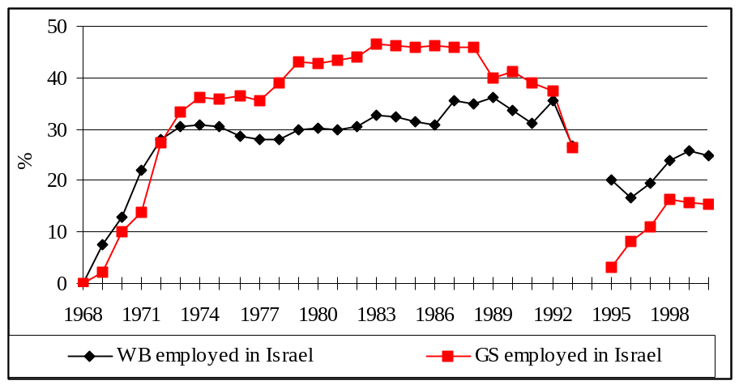
Source: Table 1

Second, the Gaza Strip could not longer rely on the Israeli labor market to absorb its labor force, as it did before 1993. The Israeli labor market absorbed less than 15% of the total Gaza Strip active labor force in mid 2000, compared to 35-45% before 1993 (Table 1). The West Bank by contrast still exported 18-25% of its labor force to Israel between 1995-1999 (compared with 25-30% in the pre-Oslo period). In mid 2000, a total of 28,600 Gaza Strip workers were employed in Israel, which is less than the total number recorded in 1978. (Table 1 and Figure 1).

Third, access to Israel has become more restricted and difficult, but more so for Gaza Strip workers than West Bankers. Ever since 1997, less than 40% of West Bank workers employed in Israeli enterprises had a permit. In the case of workers from the Gaza Strip, only those with permits could work in Israel. Moreover, despite holding such a permit, the access of Gaza Strip workers to Israel was not guaranteed (UNSCO 2001, UNSCO 200b).

Fourth, the characteristics of Palestinian workers employed in Israel and the settlements have changed slightly over time. On the one hand, flows continued to be predominated by male, unskilled and semi skilled workers. However, the average age of workers employed in Israel in 1999 was higher than in 1980. Between 1975-1987, over 42% of WBGS workers in Israel were under the age of 24 (Farsakh 1998). In mid 2000, this share dropped to less than 31.4% for West Bank workers and 7% for Gaza Strip workers (PCBS 2001b). Yet, as can be seen in Table 2, workers in settlements are found to be younger, less educated and predominantly unskilled compared with workers in Israel. In terms of sectoral concentration, over 53% of workers in 1997 and 1999 were employed in the Israeli construction sector. These shares corresponds their pre 1991 levels (see Farsakh 1998).

Last, but not least, employment in illegal Israeli settlements built in the West Bank and Gaza Strip became important. Available figures on permits for work in Israeli establishments indicate that 30% of permits given to West Bankers since 1994 were for work in the settlements (Table 2). In the Gaza Strip, fewer than 12% of permits were given for work in Israeli settlements and industrial zones. Unfortunately no accurate data are available on the number of illegal workers employed in the settlements, as many workers conceal their employment in such illegal construction [8]. However, there are reasons to believe that the actual number of West Bank workers employed in settlements is higher than reported figures and that it has continued to rise (Table 1, Figure 1). This is partly because Israeli regulations have made the access to Israeli settlements far easier than access to Israel, as will be explained below. If we were to assume that a third of those workers are employed in settlements [9], then an estimated total of 30,000 West Bank workers would have been employed in such illegal settlements in August 2000, compared with 77,000 in Israel and Jerusalem. Settlements’ expansion threatens the territorial contiguity of the West Bank and limits its ability to separate from the Israeli economy (see Map 1).

III. The determinants of WBGS labor flows

Three factors in particular continue to determine the prospects for Palestinian employment in the Israeli economy. These include the nature of Palestinian labor supply and its incentive to migrate, Israeli regulations of Palestinian labor mobility, and Israeli demand for Palestinian workers, particularly in the construction sector.

Palestinian incentives to migrate

The incentives to seek employment out of the WBGS economy has remained strong, especially in view of the fact that the Palestinian labor force has been growing by over 4.1% per annum since 1993 and is expected to grow by 4.4% per annum over the next decade (IMF 2001). By mid 2001, a total labour force of 675,000 persons were reported to be working or seeking work, which is the equivalent of 45.2% of the working age population (defined as those 15 years old and over). Participation rates have been particularly low, recorded at an average of 41.7% in the Gaza Strip and 46.9% in the West Bank (PCBS 2001c). This implies that a relatively small working force is sustaining a population growing at more than 5.1% per annum, which is one of the highest growth rates in the world today (IMF 2001).

The WBGS economy has also faced a significant unemployment problem since 1993. In contrast to the period between 1970-1993 where unemployment rates in each of the West Bank and the Gaza Strip remained lower than 7% (Farsakh 1998), unemployment rates in the post 1993 era were between 15.1-37% in the Gaza Strip and 10.1-24.2% in the West Bank (see Table 3). The number of jobless workers increased particularly in years of intensive closures, especially in 1996, and after September 2000 (see Figure 2). Unemployment usually increases the incentive to seek a job outside the domestic economy (Harris-Todaro 1970, Massey et al 1998). As can be seen from Figure 2, unemployment rates and level of participation in the Israeli labour market are inversely related. They both depend on the level of access to Israel.

Figure 2 also indicates important differences between the Gaza Strip and the West Bank. It shows that unemployment rates in the Gaza Strip remained higher than level of employment in the Israeli economy, which is another indication of the level of separation taking place between the Gaza Strip and Israel. The Gaza Strip could not rely on the Israeli economy to the extent it needed to. On the other hand, if we were to look at the situation in the West Bank, we find that unemployment rates have been typically lower than those reported in the Gaza Strip. They have also been lower than the share of the labour force employed in Israel, indicating a continuous trend of integration between the Israeli and the West Bank economies.

The ability of the domestic WBGS economy to generate enough jobs to absorb its growing labour force, and thereby to reduce the incentives to migrate, has been mixed. Between 1995-2000, the domestic economy has succeeded in generating a total of 309,000 new jobs. These outpaced the growth of Palestinian employment in Israel and helped reduce unemployment rates between 1997-1999. As can be seen from Table 3, domestic labour market absorbed more than two thirds of total employment created over the past 5 years. This contrasts with the situation between 1967-1993 where the Israeli labour market absorbed two thirds of total employment growth (Farsakh 1998).

Figure 2
a. Share of unemployed and of workers in Israel in total West Bank labour force, 1993-2001
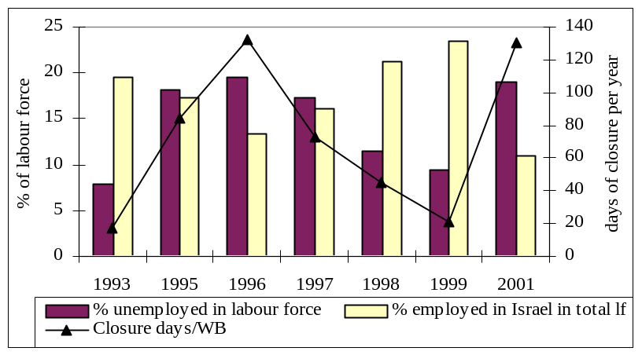
b. Share of unemployed and of workers in Israel in total Gaza Strip labour force, 1993-2001
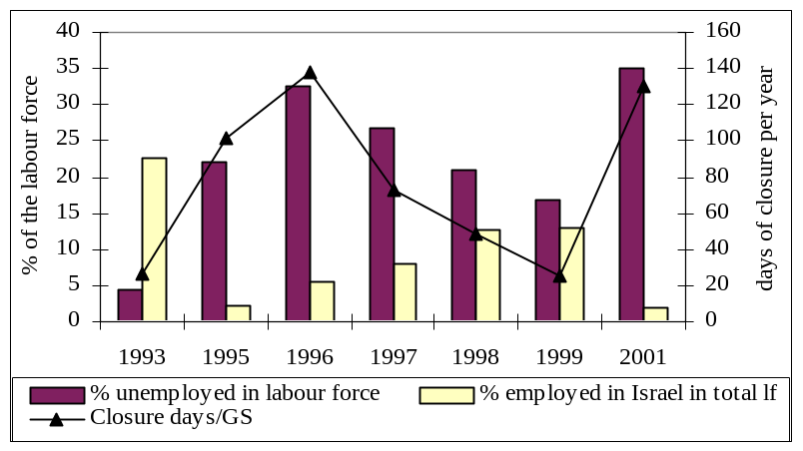
Notes: The right hand axis refers to the number of days of closure per year. The left hand axis plots the percentage of those unemployed and of those employed in Israel. Figures for days of closure in 2001 refer to the period between January and June only. Source: Calculated from tables 1 & 3

However, domestic employment growth in the post 1993 period remained dependent on Israeli closure policies. The closure imposed on the Palestinian territories since Al-Aqsa Intifada has led to massive layoff and high unemployment rates (see Table 3). Moreover, employment generation capacities varied between the West Bank and the Gaza Strip. In the Gaza Strip, most of the jobs created were in the public sector. This absorbed 25- 30% of the domestic employed work force ever since 1995. In the West Bank, the public sector represented only 18% of total employment (MAS 2000). The productivity of these jobs remained highly questionable, in view of the drain that they represent on fiscal revenues and their concentration in the police forces [10]. Meanwhile, the growth in West Bank domestic employment was not always substantially higher than the number of jobs created in Israel, as can be seen in Table 3. Between 1998-1999 in particular, the West Bank absorbed less than 45% of the increase in total employment. In the Gaza Strip, by contrast, growth of employment in the domestic economy was more important that in Israel. The domestic market accounted for 77% of all employment over this period. The large presence of West Bank workers in Israeli establishments between 1997-1999, which were years with few closure days, reflect an increase in Israeli demand for such labour as well as a relative ease of access.

The third factor influencing migration incentives are wage levels. Gaza Strip workers employed in Israel earned more than double what they would earn in the domestic sector, reflecting the strong incentive to migrate and the lack of integration between the two economies (Figure 3). The situation for West Bank workers however was different. The wage differential for workers employed in Israel versus those employed domestically converged over the years. By 2000, the wage premium for West Bank workers employed in Israel was only 30% higher than work in the domestic economy (Figure 3).

Figure 3:
The ratio of domestic to Israeli earned wages for male Palestinian workers employed in the domestic and the Israeli construction sector and the economy at large, 1996-2000
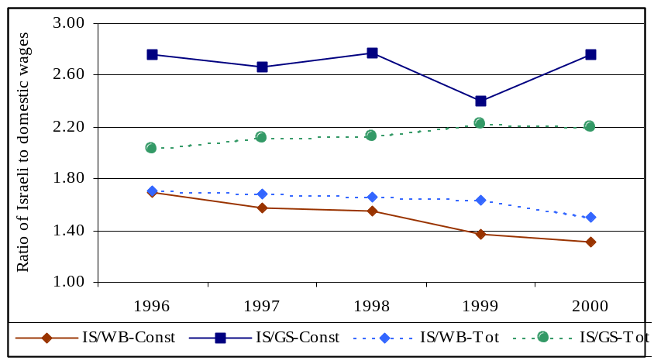
Notes: Israel/WB-const, Israel/GS-const: wages earned in Israel as a ratio of wages in the West Bank and in the Gaza Strip in the construction sector. Israel/WB-Tot, Israel/GS-Tot: wages in Israel as a ratio of wages in the West Bank and the Gaza Strip in all sectors. Source: PCBS, Labour Force Surveys, Annual Reports for 1996-2000. Ramallah.

Institutional barriers

Palestinian employment in Israel since 1993 became dependent on Israeli regulatory constraints, and particularly on Israel’s permit and closure policies. Israel’s permit policy consists of regulating the entry of workers into its area on the basis of security consideration, rather than on the basis of economic force of supply and demand [11]. Imposed since 1991, the permit policy made entry of WBGS workers into Israel conditional on obtaining a security clearance from the Israeli military establishment, as well as on acquiring a request of employment from an Israeli employer (PHRC 1992, Law 1999). The Oslo process institutionalized this system, and made it more complicated. Since 1993, Israel restricted permits to married men over the age of 28. It also shortened the duration of the permit to a period of two months, which were not always renewable. Moreover, these permits bound the workers to a specific firm and place of employment, thereby restricting their mobility.

In principle the permit policy applied to workers seeking to find a job in Israel as well as on the settlements. However, since 1993, Israel has made the conditions for issuing a permit for work in the settlements easier than for work beyond the Green Line. Workers seeking a job in a settlement did not need to be married or older than 18 years. They were also not restricted to specific hours of work. Moreover, from the employer point of view, workers’ permits for settlements were cheaper than for those employed beyond the 1967 borders. This is because Israeli employers in the settlements were exempted from paying Palestinian workers social security benefits to which they were entitled if they were employed in Israel. These amounts up to 25-30% of gross wages paid for legal Palestinian working in Israel (Farsakh 1999, Kav Laoved 1997, 2000).

The success of the permit policy in regulating labor flows has only really been possible when combined with Israel closure policy. In particular, Israel’s imposition of the closure policy has been the most effective measure in restricting the mobility of workers and in demarcating boundaries between Palestinian and Israeli areas. Imposed since 1993 as a security measure against suicide attacks, Israel’s closure policy consists of cutting the flows of goods and labor between the WBGS and Israel as well as between the WBGS and the rest of the world. In a situation of internal closure, Israel restricts mobility between the various parts of the West Bank itself and prevents any contact between the West Bank and the Gaza Strip. Between 1993-2000, Israel closed its borders with the WBGS for 484 effective days, which is the equivalent of nearly 3 months of closures a year (UNSCO 2001). During such periods no worker could get to his job in Israel, or in the settlements. As can be seen from Figure 2, the number of Palestinian workers going to Israel decreased as days of closure increased.

Israeli permits and closure policy, however, do not explain on their own why West Bank workers found it easier to access Israel and the settlements than Gaza Strip workers. The reason for why the West Bank could rely more on the Israeli labor market than the Gaza Strip is rather tied to Israel’s territorial policy in each of these two Palestinian areas. Ever since 1978, Israel has shown to be more interested in fostering territorial and economics with the West Bank than with the Gaza Strip [12]. This different Israeli territorial interest is best reflected in its settlement policy. Between 1972-1993 Israel built more than 123 settlements in the West Bank hosting 126,000 Israelis. In East Jerusalem a total of 126,000 Israelis were living in 10 settlements surrounding 130,000 Palestinians (FMEP 1999). In the Gaza Strip, by contrast, Israel built 16 settlements and the settler population did not include more than 4800 Israelis in 1993. With the Oslo process, Israel enhanced its territorial claim over the West Bank (including East Jerusalem) by building over 49 new settlements posts and by increasing the settler population from 250,000 to a total of 360,000 settlers between 1993-2000(FMEP 2001). In the Gaza Strip, by contrast, the settler population increased by less than 2000 persons over the same period. The expansion of settlements in the West Bank had an important role in fostering demand for Palestinian labor, and thereby in helping to keep labour links between the West Bank and the Israeli economies.

The fact that Israel was more interested territorially in incorporating larger part of the West Bank than of the Gaza Strip is also reflected in the way the Oslo process treated each of the two Palestinian areas. The Oslo Process has given the Palestinian Authority fuller control over the Gaza Strip than in the West Bank. By mid 2000, the Palestinian Authority controlled 85% of the land and 98% of the population in the Gaza Strip compared with 41% of the area in the West Bank (i.e. area A and B) (FMEP 2000). Israel, by contrast, continued to control fully area C, which cut 59% of the West Bank into various cantons that cannot easily dispense from their links to Jerusalem, to Israeli settlements, or to building sites on the 1967 Green Line border (see Map 1). Meanwhile, Israel choose to demarcate its border more clearly with the Gaza Strip by establishing the Eretz and Karni checkpoints and by meticulously monitoring any illegal crossing. It institutionalized a separation that it did not as strictly apply to the West Bank. With the West Bank, Israel rather kept the borders porous, thereby enabling West Bank workers to sneak illegally to work beyond the 1967 borders.

Demand for Palestinian workers in the Israeli economy

Palestinian labor flows to the Israeli economy are not solely determined by political constraints, but also by the nature of Israeli demand. In the 1980s, various segments of the Israeli economy became dependent on the supply of low cost Palestinian labor, especially as WBGS workers tended to concentrate in lows skills occupations shunned by Israelis. Palestinian workers were not found to displace Israeli workers or to effect negatively Israeli unemployment rates (Semyonov and Lewin-Epstein, Farsakh 1998). The wages of a Palestinian worker were typically 20-40% lower than the wage of an Israeli employed in the same job (Kleiman 1992). The employment of WBGS workers in Israel was found to be positively correlated to the growth of Israeli GDP between 1970-93 (Khaleefeh 1996).

However, the entry of overseas workers into the Israeli labor market since 1991 is argued to have reduced Israeli demand for Palestinian workers. By 1998, a total of 150,000-200,000 overseas workers, with and without permits, were estimated to be employed in Israel (ICBS 1998, Gesser et al 2001). This is nearly double the number of Palestinian workers employed in Israel in that year. Foreign workers are argued to provide a substitute to Palestinian workers since they tend to concentrate in low skilled jobs in which WBGS dominate [13] (Amin 2000, Batrum 1998). However, given the absence of disaggregate data on the skills, educational background and productivity of foreign workers compared with Palestinians, it is not possible to determine to what extent the formers are substitutes to the latter. What is clear is that the intake of overseas workers is tied with the closures imposed on the WBGS. It increased in years in which closures were most intensively exerted on the WBGS. The number of permits issued to overseas workers in all sectors dropped from 90,192 permits to 70,172 in 1999, which was a year in which less than 24 days of closure were imposed (IMOL 2001, UNCTAD 2001).

In order to understand the reason for the continuous absorption of Palestinian workers in Israel in the 1990s, it is necessary to analyze Israeli demand, particularly in the construction sector, where the majority of WBGS workers are concentrated. During the mid 1980s, WBGS workers represented over a third of all workers employed in this sector (Figure 4). They occupied an important niche in the sector by dominating mainly low and semi- skilled elementary construction jobs (also referred to as wet jobs). Palestinian workers were particularly attractive given that their wages were found to be 50% lower than the wages of unskilled Israeli in construction in the 1990s (ICBS 1999). The availability of WBGS workers is believed to have contributed to keeping construction costs low and in making the sector particularly labor intensive (Bar-Nathan et al 1998, Amir 2000).

The demand for Palestinian workers in the Israeli construction sector has been tied with the growth of the sector, the pattern of its geographic distribution and with the ability of cheap labor to access places of work. Available data reveal that the growth of the Israeli building industry has been large enough to stimulate the demand for all kind of workers. Between 1990-1998, the building industry grew by over 8.7% per annum, faster than the growth of the country’s GDP [14]. As can be seen from Figure 4, the number of foreign workers more than tripled between 1993-1996, increasing from 4,100 to 59,700, while the number of WBGS workers came to represent half of foreigners by 1996 (Bank of Israel 2000). This was a period marked by intensive closure. Yet after 1997, the flow of West Bank workers recovered, while the number of foreign and Israeli workers dropped. After 1998, Palestinian workers came to represent over 25% of all employees in the Israeli construction sectors (a total of 59,1000), slightly higher than the number of foreign workers (Figure 4) (Bank of Israel 2000). While the Palestinian workers did not reoccupy the central role that they had in the 1980s, they are still in demand.

Figure 4: Percentage distribution of workers in the Israeli construction sector, by ethnic group 1975-2000.
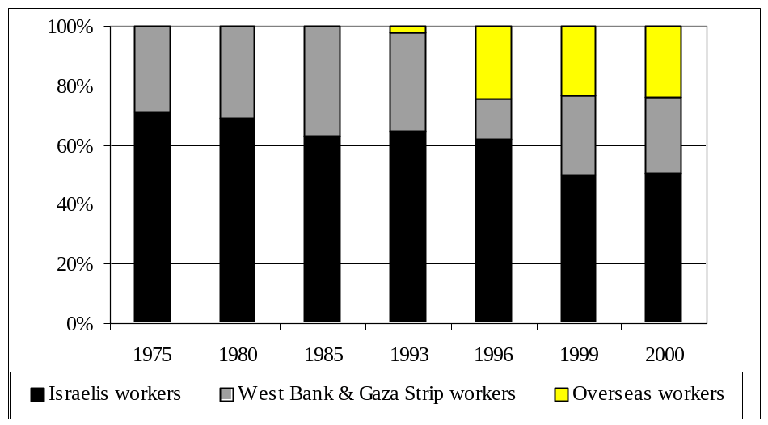
Source: Bank of Israel 2000, Table 2.A.38, ICBS, Statistical Abstract of Israel, various issues, tables 12.9, 12.7

The geographic distribution of Israeli construction has contributed to the continuous absorption of Palestinian workers. Since 1992, 30-41% of all newly built houses were constructed in the Central District, which is an area adjacent to the 1967 borderline with the West Bank [15]. Access of Palestinian workers to construction sites in this area is relatively easy since these sites are often at a 5-km distance from some parts of the West Bank towns and villages [16]. The expansion of the Central district is linked to the government’s declared plans since 1991 to shift the economic and demographic weight of the country away from Tel Aviv and the coastal axis, and towards the Center of the country and around Jerusalem (Dunsky and Golani 1992). Part of this plan is also to incorporate particular segments of the West Bank into what is the Central district of Israel (Shahar 1992).

Construction in Israeli settlements in the West Bank and East Jerusalem has also perpetuated the demand for Palestinian workers (Figure 5). Settlements are of relative easy access for Palestinian workers, particularly in period of no closure. Contractors and workers do not have to cross-checkpoints or wait long hours to reach their place of work in the settlements. Meanwhile, Israel built over 49 new settlement outposts between 1993-1999 and an average of 2300 new housing units per year in the West Bank and Gaza Strip over that period (FMEP 2000, ICBS 2000). In East Jerusalem a similar number of houses has been built annually over the same period (FMEP 2000) [17]. Moreover, over 186 miles of Israeli bypass roads have been paved and completed between 1994-1997 (Peace Now 2001). Since 1995, the annual number of new dwelling under construction in settlements has continued to grow while in Israel it dropped (Figure 5). In 1998, 9% of all Israeli construction was undertaken in the settlements. Yet, the Israeli settler population in the West Bank (including East Jerusalem) represents less than 4.2% of the total Israeli population [18].

The expansion of these settlements cuts at the heart of the territorial contiguity of the West Bank, while at the same time further incorporates certain land of the West Bank into the Central district of Israel (See Map 1). Interestingly enough, the number of new houses under construction in the settlements peaked in the years preceding the initiation of the peace process in 1993 and again during the negotiation for the final status negotiations in 1998-1999 (Figure 5). During the Al-Aqsa Intifada, in the last quarter of 2000, 954 new public funded housing units were initiated in the settlements, which is the equivalent of over 10% of all public housing starts in Israel (FMEP 2001). In the first half of 2001, construction in the settlements represented 32.6% of nationally tendered projects and 9.5% of all private housing starts (FMEP 2001).

Figure 5. New dwelling units being built in Israel and in Israeli Settlements in the West Bank and Gaza Strip
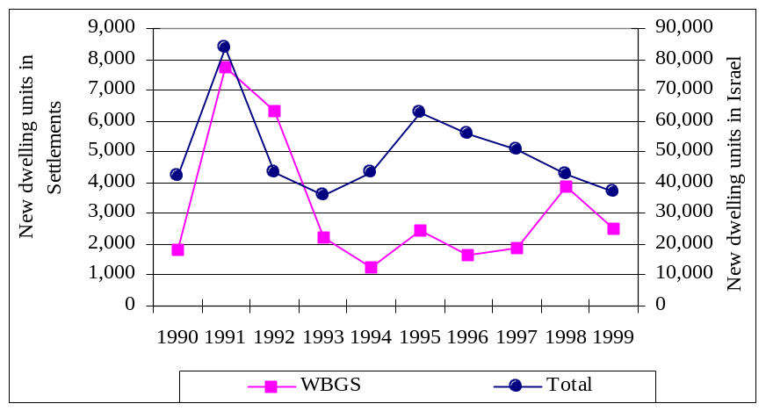
Notes: The data refers to number of dwellings whose construction has begun. Left-hand axis refers to the number of new dwelling being built in the settlements on the WBGS. Right hand axis refers to the number of total houses being built in Israeli controlled areas.
Source: Table 4, based on data from ICBS, Statistical Abstract of Israel, 1993, 1999, tables 16.4 & 16.5

Demand for Palestinian workers is also linked to their cost and how they compare with other workers. However, it is not obvious that foreign workers can replace the demand Palestinian workers for three main reasons. First, foreign workers are not always cheaper than WBGS workers. Available data indicate that it is cheaper for an Israeli employer to hire a legal overseas worker (i.e. with a permit) rather than a Palestinian worker. This is because Israeli regulations deprive overseas workers of social security benefits to which legal Palestinian workers in Israel are entitled [19] (Kav Laoved 1997). However, foreign workers are not cheaper than Palestinians who are employed in Israeli settlements in the WBGS, and for which such benefits are excluded [20].

Concerning the cost of illegal workers (i.e. those without a work permit), Amir (2000) argues that the wage of illegal foreign workers in construction is lower than the wages of an average Palestinian worker. The average hourly wage of a WBGS worker was of the order of $2.5 in 1997 (PCBS 1998). Foreign workers are reported to earn effectively $1.96-2.5 per hour (Amir 2000:8). On the other hand, Palestinians employed in the settlements earn on average $2.2 per hour [21]. In other words, they are cheaper than Palestinian workers in Israel, but not necessarily more expensive than foreign workers.

The second factor that explains the continuous demand for Palestinian workers by Israeli employer is linked to the geographic distribution of Israeli construction and to the accessibility of workers to work sites. There is reason to believe that Palestinian and overseas workers distribute in different geographic areas. Overseas workers are found to concentrate in major Israeli cities such as Tel Aviv (Gesser et al 2001). On the other hand, Israeli regulations facilitated the supply of Palestinian workers to settlements and border regions, while making it more costly for them to get to Tel Aviv or Northern areas of Israel. Palestinian contractors and workers found it easier to access Israeli construction sites within the West Bank, or along the Green Line and in the Central District of Israel, especially in years of low closures (see Map 1). As explained earlier construction in settlements, Jerusalem and the Central district represented over 50% of all construction growth since 1992.

Last, but not least, the prospects West Bank labor employment outside the domestic economy is tied to the pattern of labor recruitment in the Israeli construction sector. Foreign workers have not been always accessible to all types of Israeli construction firms. The Israeli Ministry of Labor regulates the supply of overseas workers in close coordination with the Israeli Association of Contractors and Builders. This Association, which defines the recruitment and terms of employment of these workers, has directed overseas laborers mostly towards large construction firms, thereby depriving smaller construction companies of such workers (Amir 2000). Many smaller firms had thus to revert to illegal channels of recruitment of foreign labor, mainly through illegal labor recruitment firms, or have tried to employ Palestinian workers. Illegal hiring of foreign workers, though, can entail a number of risks, especially in view of the Israeli government’s decision to fine heavily enterprises hiring illegal workers (Kav Laoved 2000).

The supply of Palestinian workers to Israeli construction firms does not pass through private recruitment firms. Rather, it is organized through a system of Palestinian subcontractors. Construction output in Israel is typically undertaken through a series of subcontracted tasks (Amir 2000, Bar-Nathan et al 1998). The mother firm that wins the bid for a construction site does not undertake the whole building works, but rather subcontracts the various works (plumbing, infrastructure, skeleton work, tiling, etc.) to smaller subcontractors. Palestinian subcontractors have come to play a pivotal role in accomplishing low skilled subcontracted jobs ever since the 1980s. They provide their main Israeli contractor with workers needed for the job, while at the same time free the construction firm from the responsibility of directly paying the workers or keeping them on site once the project is over. They are also accessible to any firm of any size.

From the Israeli firm point of view, the subcontracted arrangement increases the competitiveness of the sector while at the same time frees the main construction firm from the burden of workers’ control and payments. While foreign workers have also been found to be increasingly involved in subcontracted arrangements with Israeli firms (Amir 2000), it is not yet clear how far foreign subcontractors can replace Palestinian subcontractors. Israeli contractors have often built long-standing trust relation with Palestinian contractors with whom they speak in Hebrew. It will take some time still for such relations to be established with foreign companies. Moreover, from the Israeli government's point of view, Palestinian contractors and workers are preferred to foreigners because they return home at the end of a day's work. They thus do not burden the Israeli society with costs of accommodation or integration as foreign workers do.

IV. Conclusion

Palestinian labor flows to Israel are yet not over. Since 1993, developments in the pattern of WBGS commuting migration show that a process of separation and redefinition of economic and territorial boundaries has been taking place between the Israeli and the WBGS economies. On the one hand, the labor links between Israel and the Gaza Strip have been severed and the two economies have been separating. This separation, though, has not been the result of an internal capacity of the Gaza Strip economy to absorb its growing labor force or to reduce it dependence on the Israeli product and labor markets. Rather the separation between the two economies has been the result of Israel’s successful restriction of Gaza Strip labor outflows. The success of Israeli restrictions is attributed not only to Israel’s permit and closure policy, but also to Israel’s clear demarcation of its borders with the Gaza Strip.

On the other hand, the labor links between Israel and the West Bank have been maintained and the two economies have not yet separated. The West Bank continues to rely on the Israeli labor market to absorb its growing labor force, albeit at fluctuating levels and depending on Israel’s closure policy. The fact that Israel has not defined its borders clearly with the West Bank, the way it did with the Gaza Strip, also helps explain why the flow of West Bank workers persisted during the interim period. Meanwhile, the growth of the construction sector in Israel, particularly in Central areas that border the West Bank and in the settlements, has maintained a demand for West Bank workers despite the arrival of overseas workers. The expansion of these areas will determine the final status borders between Israel and the West Bank. Until these are defined, Israeli demand for Palestinian workers might well continue.

The Al-Aqsa Intifada in September 2000, and the closure imposed since on whole of the Palestinian territories, might well indicate that borders will be finally demarcated. They suggest that the role of labor in integration the West Bank and the Israeli economies might also be over soon, for political rather than economic reasons. However, between July and September 2001 Israel announced the construction of further 10 settlements in the area and a total of 42,000 Palestinians were reported to work in Israeli areas [22]. Such developments suggest that the process of territorial integration through the use of cheap Palestinian labor might continue, at least not until the final status peace agreement is reached.

ENDNOTES

[1] According to the 4th Geneva Convention which applies to the WBGS which Israel occupied in 1967, an occupying power has no right to change the demographic character of the area it occupies or to incorporate part of the land it controls. Israel’s annexation of East Jerusalem and the construction of Israeli settlements in the rest of the West Bank and Gaza Strip are thus illegal from an international law point of view. They also compromise the territorial integrity of the WBGS, which the Oslo process promised to preserve (Article IV, Oslo I).

[2] The Economic Protocol, referred to as the Paris Protocol, forms annex V of the Interim Agreement signed on September 28th 1995 (Oslo II). The Palestinian-Israeli Declaration of Principles on Interim Self-Government Authority (DOP) signed on September 13th 1993, and the Interim Agreement on which it is based, are the central documents of the Oslo peace process.

[3] These issues were deferred to the final status negotiations. See article V.3 of the Palestinian-Israeli Declaration of Principles on Interim Self-Government authority (DOP).

[4] The list of goods that the Palestinian economy was allowed to import from non-Israeli sources included lists A1, A2, and B.

[5] It grew by less than –2.4% in 1995 and –3.2 in 1996. In 1999 it was recorded at 6.0% (IMF 2001).

[6] The figure on unemployed refers to all those who did not work for an hour during the week of the survey (this is the ILO definition). If the number of workers discouraged from searching for jobs were added to this figure, the total share of unemployment would be of the order of 35.5% in June 2001 (PCBS 2001c). Poverty is defined as all households (two adults and four children) earning less than $1642 per month, which is less than $2.1 per day (PCBS 2001a).

[7] They represent less than 23% of total trade with Israel (UNSCO 2000a)

[8] Workers are reluctant to admit that they work in settlements, ever since the PNA declared in 1996 that such work is illegal and will be penalized.

[9] Which is the ratio given for workers with permits (see UNSCO 200b).

[10] It is estimated that 55,000 jobs out of 80,000 jobs created in the public sector between 1994-1999 were in the police forces (IMF 2001).

[11] Farsakh (1998)

[12] Ever since the Drobles Settlement Master Plan in 1978 and the Camp David Agreement in 1979, Israel has decided to consolidate its settlements in the East Jerusalem and in its metropolitan area, as well as in the rest of the West Bank (Aronson 1996).

[13] Official data also reveal that 25% of all overseas workers are concentrated in the agricultural sector (ICBS 2000, table 12.6). This is higher than the share occupied by WBGS workers (legal and illegal). PCBS (2000c) reports that only 12% of all WBGS workers employed in Israel work in agriculture. Overseas workers are also found to concentrate in the service sector, particularly in domestic services as well as in semi skilled jobs such as nursing (Gasser et al 2001). These are sectors in which Palestinians are not present.

[14] Based on data calculated from the Bank of Israel 2000, table 2.A.37. The growth of the sector was mainly instigated by the intake of over 980,000 new immigrants over this period, an intake that lead to an increase of 31% in total Israeli population by the end of 1999.

[15] Calculated from Source: ICBS, Statistical Abstract of Israel, 1993, 1996, 1999, tables 16.4 and 16.5

[16] Particularly in the case of towns such as Qalqilia, Tulkarem and villages around the Latrun area and around Modiin along the Green Line.

[17] In Maale Adumin, a settlement in the metropolitan district of Jerusalem, over 700 new units were accepted for construction in November 2000. This settlement had a total population of 22,000 settlers in 1999 (FMEP 2000).

[18] Calculated from ICBS, SAI 2000, tables 2.2 and 5.5

[19] These benefits represent 27% of legal workers’ gross wages in Israeli construction (Kav Laoved 1997)

[20] Overseas workers and Palestinians employed on Israeli settlements in the WBGS are not entitled to pension and end of service bonus to which Palestinian workers in Israel are entitled. They are given basic national insurance coverage, which is paid by the employer, and amounts to less than 1% of gross wages. Workers also get health insurance, which is mainly paid by themselves (Kav Laoved 1997).

[21] PCBS 2000 unpublished data on workers' wages in the settlements.

[22] See the Peace Now (2001) and PCBS (2001c).

REFERENCES

Abu-Shokor, A. Socio-Economic Conditions of West Bank and Gaza Strip Workers in Israel. Palestine: Najah University, 1987. (Arabic).

Amir, S. “Overseas Foreign Workers in Israel: Policy Aims and Labour Market Outcomes”, Maurice Falk Institute for Economic Research in Israel, discussion paper A00.01, 2000.

Aronson, G. Settlements and the Israel-Palestinian Negotiations: An overview, Final status issues paper, Washington, D.C: IPS, 1996.

Arnon, A, Luski, I., Spivak, A. and Weinblatt, J. The Palestinian Economy: Between Imposed Integration and Voluntary Separation. Leiden: Brill, 1997.

Arnon, A. and J.Weinblatt. “Sovereignty and Economic Development: The case of Israel and Palestine”, The Economic Journal, (111),pp. 291-308, 2001.

Astrup, C. and S. Dessus. “Trade Options for the Palestinian Economy: Some Orders of Magnitude”, Middle East and North Africa Working Paper Series No.21 Washington, D.C.: World Bank, 2001.

Bank of Israel. Annual Report 1998, Jerusalem, 1999.

Bank of Israel. Annual Report 1999, Jerusalem, 2000.

Bar-Nathan, M. Beenstock and Y.Haitovsky. “The market for housing in Israel”, Regional Science and Urban Economics, 1998, (28), pp. 21-49.

Batrum, D. “Foreign Workers in Israel: History and Theory”, International Migration Review, 1998, 32, (2), pp. 303-325.

Diwan, I. And R.Shaban. Development under Adversity: The Palestinian Economy in Transition. Washington: MAS-World Bank Joint Report, 1999.

Dunsky, N and Y. Golani. “The Star Plan- The Hills Axis”, in Golani et al (eds), Planning and housing in Israel in the Wake of Rapid Changes, Israel: Ministry of Interior and Ministry of Construction and Housing, 1992, pp. 82-96.

Farsakh, L. Palestinian Employment in Israel 1967-1997: A Review, Ramallah: MAS, 1998.

Farsakh, L. The Implementation of Labour Related Articles in the “Protocol on Economic Relations between Israel and the PLO”:A Critical Assessment, MAS. Ramallah, 1999.

Foundation for Middle East Peace (FMEP). Report on Settlements in the Occupied Territories, Washington, D., May 1997, 7 (3).

Foundation for Middle East Peace, Report on Settlements in the Occupied Territories, Washington, D.C, May 1999, 9 (3).

Foundation for Middle East Peace, Report on Settlements in the Occupied Territories, Washington, D.C., December 2000, 10 (4).

Foundation for Middle East Peace, Report on Settlements in the Occupied Territories, 2001, 11 (6), Washington, D.C.

Gesser, S C, R.Raijman, A.Kemp, and J.Reznik, “Making it in Israel: Latino Undocumented Migrant Workers in the Holy Land”, Estudios Interdisplinario de America Latina y et Carribbe, 2001, 11 (2).

Harris, J. and Todaro, M. “Migration, Unemployment and Development: A Two-sector Analysis”. The American Economic Review, 1970 (60), pp. 126-142.

IMF, West Bank and Gaza Strip: Economic Performance, Prospects and Policies, Middle Eastern Department, Washington: IMF, 2001.

Israeli-Palestinian Interim Agreement on the West Bank and the Gaza Strip, (Oslo-II), (and its Protocols), Washington, 28th September 1995.

Israeli Central Bureau of Statistics, Report to the Press, July, Jerusalem, 1998.

Israeli Central Bureau of Statistics, Statistical Abstract of Israel, Jerusalem, 2000

Israeli Central Bureau of Statistics, Statistical Abstract of Israel, various issues Jerusalem

Israeli Ministry of Labour (IMOL), Israeli Employment Office Foreign labour data (unpublished data), Jerusalem

Khaleefeh, M., “Demand for Palestinian labour in Israel and the Occupied Territories”. Unpublished MA thesis, University of Yarmook, Jordan, 1996.

Kav Lavoed (Workers’ Hotline). Foreign Workers in Israel, Newsletter, March 1997.

Kav Lavoed (Workers’ Hotline). Palestinian Workers in Jewish Settlements, August 1998 .

Kav Lavoed (Workers’ Hotline). Foreign Workers in Israel. Newsletter, May, 2000.

Kleiman, E. “The Flow of Labour Services from the West Bank and the Gaza Strip” Hebrew University (Jerusalem) Working Paper No. 260, 1992.

LAW. Right to Work: Economic Rights under Military Occupation, Jerusalem, November 1999.

MAS-Palestine Economic Research Institute. The Economic Monitor, (6). Ramallah, 2000.

MAS- Palestine Economic Research Institute. The Economic Monitor, (7) Ramallah, 2000.

Massey, D. et al. Theories of International Migration, Cambridge: Harvard University Press, 1998.

Palestinian Central Bureau of Statistics . Labour Force Survey, (18), Ramallah, 2000a

Palestinian Central Bureau of Statistics. Labour Force Survey: Annual Year Report 1999. Ramallah, 2000b.

Palestinian Central Bureau of Statistics. Impact of Israeli Measures on the Economic Conditions of Palestinian Households, Ramallah, July-August 2001a.

Palestinian Central Bureau of Statistics. Labour force data, 2001b. at hptt://www.pcbs.org/
laborforce.html

Palestinian Central Bureau of Statistics. Labour Force Survey, (21), 2001c, at hptt://www.pcbs.org/laborforce.html

Palestine Human Rights Information Centre (PHRIC). The Impact of the Work Permit System on Palestinian Workers in Israel. Jerusalem, September 1992

Palestinian Ministry of Labour. Work Permits to Israel, Israeli Settlements and Industrial Zones, Ramallah, 2000

Peace Now. Report on Settlements Activities, 2001, www.Peacenow.org/nia/pr/10042001.html

Roy, S. The Gaza Strip, the Political Economy of De-Development, Institute of Palestine Studies, Washington, 2001

Semyonov, M., and Lewin-Epstein, N. Hewers of Wood and Drawers of Water: Noncitizen Arabs in the Israeli Labour Market. New York: Cornell University Press, 1987

Shahar, A. “Developing Plan for Jerusalem-Tel Aviv Intermetropoliltan Region” in Golani al (eds), Planning and housing in Israel in the Wake of Rapid Changes, Israel: Ministry of Interior and Ministry of Construction and Housing, 1992, pp. 57-68

UNSCO. Report on the Palestinian Economy: with Special Report on Palestinian Merchandise Trade, Jerusalem, 2000a.

UNSCO. West Bank and Gaza Strip Work Permits to Israel, Israeli Settlements and Industrial Zones, Jerusalem, 2000b

UNSCO. The Impact on the Palestinian Economy of the Recent Confrontations, Mobility Restriction and Border Closures, 1 October 2000-31 January 2001, Jerusalem, 2001 www.arts.mcgill.ca/mepp/unsco/unfront.html.

United Nations Conference on Trade and Development (UNCTAD). Review of Labor and Employment Trends in the West Bank and the Gaza Strip. UN: Geneva, 1995

World Bank. Developing the Occupied Territories: an Investment in Peace, Washington. D.C., 1993

World Bank. The Impact of Prolonged Closure on Palestinian Poverty, special report from the West Bank and Gaza Office, November 2000

World Bank. The West Bank and Gaza Update, the World Bank Group Quarterly publication of the West Bank and Gaza office, June 2001

Table 1: Palestinian Employed in the West Bank and Gaza Strip (WBGS)* by Place of Employment, ('000 and %)
Year |  | WB employed in |  |  |  | GS | employed in |  |  | Total OT
 | Domestic | Israel | Total | % in Israel | Domestic | Israel | Total | % in Israel | Domestic | Israel |  | Total | % in Israel
1970 | 99.9 | 14.7 | 114.6 | 12.8 | 52.8 | 5.9 | 58.7 | 10.1 | 152.7 | 20.6 |  | 173.3 | 11.9
1971 | 91.2 | 25.6 | 116.8 | 21.9 | 51.5 | 8.2 | 59.7 | 13.7 | 142.7 | 33.8 |  | 176.5 | 19.2
1972 | 90.3 | 34.9 | 125.2 | 27.9 | 46.1 | 17.5 | 63.6 | 27.5 | 136.4 | 52.4 |  | 188.8 | 27.8
1973 | 87.8 | 38.6 | 126.4 | 30.5 | 45.4 | 22.7 | 68.1 | 33.3 | 133.2 | 61.3 |  | 194.5 | 31.5
1975 | 91.9 | 40.4 | 132.3 | 30.5 | 46.5 | 25.9 | 72.4 | 35.8 | 138.4 | 66.3 |  | 204.7 | 32.4
1976 | 92.6 | 37.1 | 129.7 | 28.6 | 48.3 | 27.8 | 76.1 | 36.5 | 140.9 | 64.9 |  | 205.8 | 31.5
1979 | 93.0 | 39.8 | 132.8 | 30.0 | 45.3 | 34.3 | 79.6 | 43.1 | 138.3 | 74.1 |  | 212.4 | 34.9
1980 | 94.2 | 40.6 | 134.8 | 30.1 | 46.4 | 34.5 | 80.9 | 42.6 | 140.6 | 75.1 |  | 215.7 | 34.8
1984 | 104.0 | 50.1 | 154.1 | 32.5 | 47.0 | 40.2 | 87.2 | 46.1 | 151.0 | 90.3 |  | 241.3 | 37.4
1985 | 103.7 | 47.5 | 151.2 | 31.4 | 49.2 | 41.7 | 90.9 | 45.9 | 152.9 | 89.2 |  | 242.1 | 36.8
1986 | 114.5 | 51.1 | 165.6 | 30.9 | 50.5 | 43.4 | 93.9 | 46.2 | 165.0 | 94.5 |  | 259.5 | 36.4
1987 | 114.0 | 62.9 | 176.9 | 35.6 | 54.4 | 46.0 | 100.4 | 45.8 | 168.4 | 108.9 |  | 277.3 | 39.3
1988 | 119.0 | 64.0 | 183.0 | 35.0 | 53.5 | 45.4 | 98.9 | 45.9 | 172.5 | 109.4 |  | 281.9 | 38.8
1989 | 115.4 | 65.4 | 180.8 | 36.2 | 59.2 | 39.5 | 98.7 | 40.0 | 174.6 | 104.9 |  | 279.5 | 37.5
1990 | 128.0 | 65.0 | 193.0 | 33.7 | 61.0 | 43.0 | 104.0 | 41.3 | 189.0 | 108.0 |  | 297.0 | 36.4
1991 | 123.4 | 56.0 | 179.4 | 31.2 | 65.5 | 42.0 | 107.5 | 39.1 | 188.9 | 98.0 |  | 286.9 | 34.2
1992 | 132.1 | 72.5 | 204.6 | 35.4 | 71.6 | 43.1 | 114.7 | 37.6 | 203.7 | 115.6 |  | 319.3 | 36.2
1993 | 147.7 | 53.6 | 201.3 | 26.6 | 84.4 | 30.4 | 114.8 | 26.5 | 232.1 | 84.0 |  | 316.1 | 26.6
1995 | 186.7 | 47.3 | 234 | 20.2 | 68.9 | 4.6 | 75.0 | 3.3 | 255.7 | 51.9 |  | 309.0 | 16.8
1996 | 221.0 | 44.0 | 265 | 16.6 | 86.3 | 10.0 | 97.0 | 8.1 | 307.3 | 54.0 |  | 362.0 | 14.9
1997 | 243.9 | 59.1 | 303 | 19.5 | 101.4 | 13.3 | 121.0 | 11.0 | 345.3 | 72.4 |  | 424.0 | 17.1
1998 | 275.1 | 86.9 | 362 | 24.0 | 122.2 | 23.5 | 145.0 | 16.2 | 397.4 | 110.4 |  | 507.0 | 21.8
1999 | 286.0 | 100.0 | 386 | 25.9 | 140.4 | 26.1 | 166.0 | 15.7 | 426.5 | 126.0 |  | 552.0 | 22.8
2000 | 323.4 | 107.5 | 430 | 25.0 | 157.2 | 28.6 | 185.8 | 15.4 | 480.5 | 136.1 |  | 615.8 | 22.3
Notes: Figures for the West Bank exclude East Jerusalem between 1968-93 and include it afterwards.
Figures refer to total employment (includes also the underemployed, but excludes the unemployed). 1994 figures are not available.
PCBS, Labor data refer to yearly averages, except for figures for 2000 which refer to July-September labour Force Surveys (no.18)
Sources: calculated from ICBS, Statistical Abstract of Israel, various issues. ; PCBS 2000, Labor Force Survey various issues
Table 2: Economic Characteristics of West Bank and Gaza Strip (WBGS) workers employed in Israel compared with those employed on Israeli settlements in the West Bank (WB), 1998 and 2000

 | 1998 |  |  | 2000
% Distribution | WBGS workers in Israel & settlements |  | WB workers in settlements only | WBGS workers in Israel & settlements | WB workers in settlements only
Age distribution
15-24 | 29.9 |  | 40.2 | 24.9 | 43.4
25-34 | 26.4 |  | 38.5 | 24.0 | 34.6
35-44 | 23.6 |  | 14.8 | 23.3 | 17.7
45 and older | 25.8 |  | 6.5 | 25.8 | 4.3
Years of schooling
0-6 | 36.0 |  | 24.2 | 33.8 | 21.6
7-9 | 28.7 |  | 35.0 | 31.8 | 43.2
12-10 | 25.0 |  | 32.5 | 24.5 | 31.6
13 | 8.1 |  | 8.3 | 7.9 | 3.6
Sectoral distribution
Agriculture | 10.2 |  | 23.1 | 9.0 | 19.5
Industry | 12.2 |  | 18.6 | 14.5 | 17.1
Construction | 55.2 |  | 42.1 | 55.5 | 52.9
Services | 22.4 |  | 16.2 | 21.0 | 10.5
Occupation
Skilled | 44.1 |  | 39.2 | 48.3 | 37.3
Unskilled | 47.3 |  | 54.1 | 41.1 | 58.4
Notes:
Skilled workers refers to those define as craft workers and machine and plant operators. (PCBS definition)
Data refers to July-September labour survey in 1998 and 2000
Source:
PCBS 2001, Labour Force Survey, no.18, 2000, at www.pcbs.org/english/labor/round18/lbr18_05.htm;
lbr18_07.htm, lbr18_09.htm; lbr18_11.htm
PCBS 2001, selected data on West Bank workers in Israeli settlements, unpublished data.

Table 3: Palestinian Labor Force in the WBGS 1995-2001 (figures in ‘000, unless otherwise noted)

 |  | West Bank
 | change in number | of employed
Year | Domestic | Israel | Total | No. of unemployed | % unemployment | size of labour force
1995-1996 | 34.3 | -3.3 | 31.0 | 77.0 | 19.6 | 342.0
1996-1997 | 22.9 | 15.1 | 38.0 | 74.0 | 17.3 | 377.0
1997-1998 | 31.2 | 27.8 | 59.0 | 52.0 | 11.5 | 414.0
1998-1999 | 10.9 | 13.1 | 24.0 | 44.0 | 9.5 | 430.0
1999-2000 | 37.3 | 7.5 | 44.0 | 38.0 | 7.2 | 468.0
2000-2001 | -66.5 | -77.0 | -143.4 | 115.4 | 24.2 | 477.0
1995-2000 | 136.6 | 60.2 | 196.0
 |  | Gaza Strip
 | change in number | of employed
Year | Domestic | Israel | Total | No. of unemployed | % unemployment | size of labour force
1995-1996 | 17.4 | 5.4 | 22.0 | 55.0 | 32.5 | 152.0
1996-1997 | 15.1 | 5.5 | 24.0 | 47.0 | 26.8 | 168.0
1997-1998 | 20.8 | 10.2 | 24.0 | 39.0 | 20.9 | 184.0
1998-1999 | 18.2 | 2.6 | 21.0 | 35.0 | 16.9 | 201.0
1999-2000 | 18.6 | 2.9 | 22.0 | 35.5 | 15.1 | 223.5
2000-2001 | -40.0 | -25.0 | -65.0 | 73.3 | 37 | 198.0
1995-2000 | 90.1 | 26.5 | 113.0
 | Total West Bank | and Gaza Strip
 | change in number | of employed
Year | Domestic | Israel | Total | No. of unemployed | % unemployment | size of labour force
1995-1996 | 51.7 | 2.1 | 53.0 | 132.0 | 23.8 | 494.0
1996-1997 | 38.0 | 20.5 | 62.0 | 121.0 | 20.3 | 545.0
1997-1998 | 52.0 | 38.0 | 83.0 | 92.0 | 14.4 | 599.0
1998-1999 | 29.1 | 15.7 | 45.0 | 79.0 | 11.8 | 631.0
1999-2000 | 55.9 | 10.4 | 66.0 | 72.5 | 10.1 | 690.5
2000-2001 | -106.4 | -102.0 | -208.4 | 188.7 | 28 | 675.0
1995-2000 | 226.8 | 86.7 | 309.0
Notes: the number and figures on unemployment and labour force refer to reported figure at end of year.
Except for 2000 figures which refer to the third quarterly labour survey, the data provided here refer to yearly averages
Figures for 2001 refer to April-June labour force survey
Source: PCBS, Labor Force Survey, various issues. Ramallah

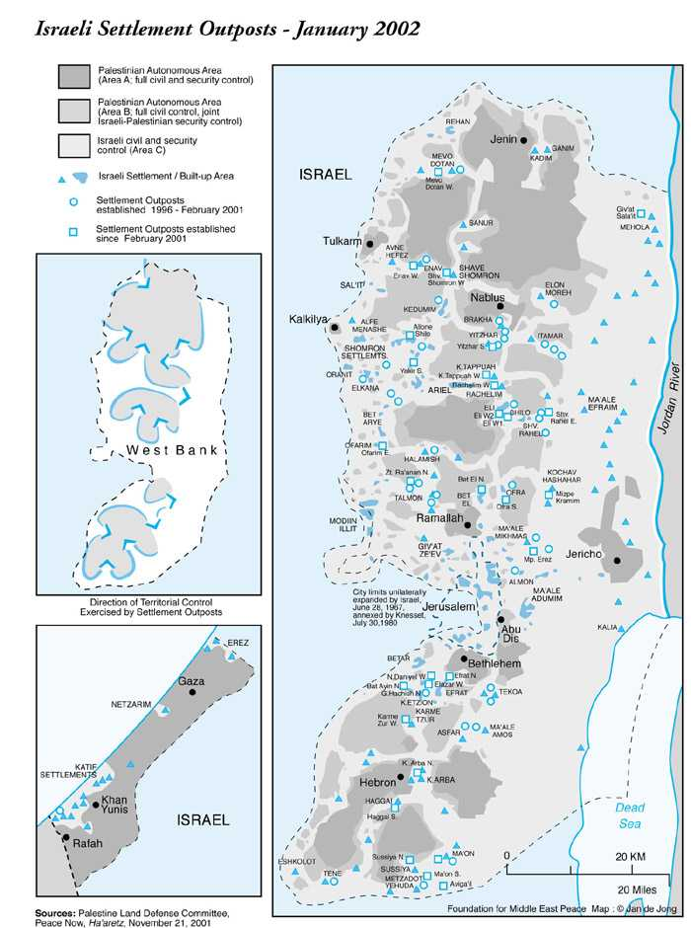

Available at: Foundation for MiddleEast Peace www.fmep.org/reports/2002/v12n1_p5_lg_map.html

