Copyright License Agreement

Presentation of the articles in the Topics in Middle Eastern and North African Economies was made possible by a limited license granted to Loyola University Chicago and Middle East Economics Association from the authors who have retained all copyrights in the articles. The articles in this volume shall be cited as follows: Zuzana Brixiova, Edward R. Gemayel, and Mona Said “Can Fiscal Decentralization Contribute to Poverty Reduction? Challenges Facing a Low Income Country", Topics in Middle Eastern and North African Economics, electronic journal, Volume 5, Middle East Economic Association and Loyola University Chicago, September, 2003. http://www.luc.edu/publications/academic/

Can Fiscal Decentralization Contribute to Poverty Reduction?

Challenges Facing a Low Income Country

Zuzana Brixiova, Edward R. Gemayel, and Mona Said^{[1]}

International Monetary Fund

E-mail: zbrixiova@imf.org; egemayel@imf.org; ms101@soas.ac.uk;

JEL CODES: I3, H5, O1

Abstract

This paper examines the link between fiscal decentralization and poverty alleviation in Sudan, since the move to federalism in the mid 1990. As a central component of poverty is to reduce inter-regional inequalities in income and improve social indicators inherited from the centralized systems, we focus our analysis on trends in regional disparities in poverty and social service delivery, by looking at the evolution in federal and state budgetary outlays on education, health and water. The findings of the paper suggest that after more than five years of fiscal decentralization, total spending on the social sectors is still very low in Sudan and there is only evidence of decentralization of spending on health, but not education. More crucially, decentralization has thus far not led to a marked improvement in social service delivery in Sudan. Some indicators such as infant mortality, malnutrition and adult illiteracy rate have improved over this period, yet most other important indicators have either stagnated or even deteriorated. The paper ends with lessons from the relatively more successful decentralization experiences of Ethiopia and Uganda.

Introduction
With an annual per capita income of around US$360 and with an estimated 50 percent of the population living on less than US$1 a day, Sudan was among the poorest countries in the world in 2000. Most available surveys also highlight a clear regional dimension to poverty in Sudan, with the poorest Northern states being those in Darfour, Kordofan and the Eastern regions. Limited available data on the Southern states indicate that poverty related problems in this area are even more acute.

Sudan’s experience with fiscal decentralization is a particularly interesting case to study for several reasons. First, Sudan is the largest country in Africa and the tenth largest in the world and is both ethnically and religiously diversified. Second, it is rich in natural resources (i.e. oil, gold...etc), which also are geographically concentrated. Finally, it is a country that has been in conflict since its independence in 1956, except for a short period between 1972 and 1983 which has been associated with a widespread rural and urban poverty with a clear regional dimension as noted above.

The paper is organized as follows. Section II reviews literature on decentralization, with particular emphasis on decentralization of health and education in developing countries. Section III provides an overview of the main institutional features of the Sudanese federal system and developments in state budgets. Section IV then analyses poverty trends and social indicators in Sudan based on data from multiple indicator cluster surveys and links these to outlays on social services. Section V concludes by drawing some lessons from the successful decentralization experiences in East Africa for Sudan.

Conceptual Issues and Cross-county Experience in Decentralization
The majority of the literature defines decentralization as being the process that transfers both authority and responsibility from the central government to subordinate governments. Fiscal decentralization strives to increase self-sufficiency of local governments as well as efficiency in the delivery of services. Brosio (2000) examines experiences with fiscal decentralization in Africa and observes that decentralization typically leads to shift from local expenditures on administration to those on health and education; however current expenditures (salaries) tend to absorb most of the increases. African countries are particularly prone to capture by local interest and local governments often have very limited taxing powers, leading to dependency on transfers from the central government. Tanzi (2000) acknowledges that decentralization might be necessary from a political point of view, but points to some possible negative consequences of decentralization, such as increased corruption, excessive regulation, difficulties in introducing efficient tax reform and difficulties in maintaining macrostability.

A more positive assessment of decentralization is presented by Von Braun and Grote (2000) who note that decentralization can reduce poverty both directly, through better targeting to regions/individuals with greatest needs and indirectly, through increase efficiency of provisioning of public services. Using cross-country data, the authors find a strong positive relationship between political decentralization and human development index of UNDP. Regarding fiscal decentralization, the authors claim that health performance generally improves with higher subnational spending, but education does not.

The above findings are consistent with results of sectoral studies. Winkler’s (1989) cross country study of educational decentralization finds that decentralization policies are most successfully implemented when local governments have their own sources of revenues, when the pressures for decentralization originate within the communities rather than from the central government, and administrative capacity at the local level is adequate or quickly developed. Using a panel data on infant mortality rates, GDP per capita, and the share of public expenditures managed by local governments, Robalino, Picazo, and Voetberg (2001) examine whether fiscal decentralization improves health outcomes (measured by infant mortality rates). They find that fiscal decentralization is associated with lower infant mortality rates, in particular in case of poor countries. Positive effects of fiscal decentralization increase in countries with strong political rights, where communities can better influence policy making at the local level. Fiscal decentralization tends to be less effective in countries with high-level of ethno-linguistic fractionalization and speculate that this is due to coordination failures.

In sum, recent cross-country studies point to two essential components to determine success if fiscal decentralization in achieving social service delivery and poverty alleviation targets: (i) strong revenue raising and administrative capacity at the local level and (ii) successful political decentralization which enables local communities to influence policymaking.

Fiscal Decentralization in Sudan
The process of fiscal decentralization in Sudan started in 1995 when proclamations were issued increasing the number of states from 9 to 26 and defining powers and revenue-sharing agreements of the federal and state governments. Subsequently, Sudan started operating a federal system with three tiers – federal, state and local. The principles of the federal system were enshrined in the Constitution.

Institutional Setup
Although all levels of governments have their own independent sources of revenues, yet the federal government collects most important revenues. The Constitution assigns to the federal government the power to collect customs revenues, business profit taxes, personal income taxes, and VAT. In addition to tax revenues, the federal government accrues non-tax revenues, mainly from oil. States have three distinct sources of revenues: (i) transfers from the federal budget through the National State Support Fund (NSSF); (ii) off-budget transfers from the federal government of 43 percent of VAT collection, and 10 percent of public enterprise profits; and (iii) revenues collected directly by the states through taxes, fees, and user charges. Local government revenues comprise of taxes on property, local transportation, local livestock production (40 percent of which is transferred to the state governments), and other local taxes or duties, as well as transfers from the state governments of some profits from public enterprises.
States’ budgets are prepared by the council of state ministers and approved by the State Assembly. The states can freely allocate their financial resources, except federal transfers through the NSSF, which are earmarked for specific capital or social development projects. States’ expenditures are broadly set in the constitution; with the main outlays going for primary health care, basic education, and safe drinking water. The allocation, through the NSSF, of funds among the different states is based on a set of criteria, which are: financial performance; population density; availability of natural resources; human resources expertise; adequacy of available infrastructure; education level; availability of health services; security situation; and average per capita income. The High Council on Resources (HCR) allocates to the states their share of the VAT and public enterprise profits. The HCR designates the public enterprises or joint ventures whose profit is to be allocated to the states and determines each state’s share.

Developments in State Budgets
The structure of government expenditures has changed markedly in Sudan since 1995. Prior to that year, the share of federal expenditures in total outlays was increasing at the expense of the share of the states. As Table 1 below shows, the implementation of fiscal federalism has led to an increase in the share of regional government expenditures in GDP from a meager 0.3 percent in 1995 to 1.9 percent in 2001, and it is expected to reach 2.7 percent of GDP in 2002. At the same time, the share of the federal government in GDP doubled during this period. Correspondingly, the ratio of state expenditures in central government expenditures steadily increased during this period, in particular in 2002.
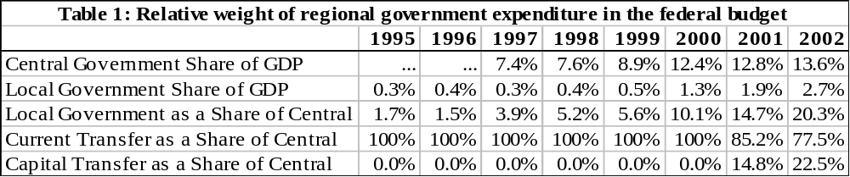
Like in many other African countries, revenue and expenditure assignments in Sudan have given rise to a vertical imbalance within intergovernmental finances. Share of capital spending in total expenditures varies greatly among states. While Khartoum allowed in 1999 around 45 percent of its total expenditures for capital outlays, only few states spent more than 10 percent. Large differences also exist in revenue-raising capacities among states, and concentration in state revenue collections has increased significantly recently. While Khartoum accounted for almost 40 percent of total revenue collection by states in 1996, its share increased to 50 percent in 1999, and is estimated to have increased further by 2001 (Table 2). To eliminate partly the resulting horizontal imbalance among states, the share of transfers to the three poorest states (Northern Kordofan, West Kordofan and Blue Nile) in total transfers increased from 8 percent to 20 percent, while share of Khartoum decreased from 21 percent to 5 percent between 1996 and 1999.
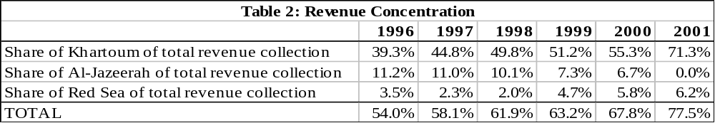

Main Reform Issues for State Finances
High spending, weak revenues, and administrative shortcomings characterize state finances in Sudan. Consequently, federal authorities took several measures that aimed at strengthening state finances. First, the increased their financial support to states. In fact, when measured against GDP, the federal support for the states has increased in terms of GDP, and the number of states receiving recurrent support from the NSSF has increased from 19 to 23. These developments are reflected in the expansion of expenditures on social services provided by the states, especially on education and health (see Appendix: Figure 1). Second, the authorities intend to improve the transparency of state fiscal operations by setting up a monitoring and evaluation unit at NSSF to ensure timely implementation of the state budgets. Finally, authorities intend to harmonize tax policies among states in order to limit tax competition among the different states eliminate illegal tax transiting.

Poverty Trends and Social service Delivery Since Decentralization
Recent research and surveys indicate that poverty in Sudan is widespread, and perhaps even growing during the period preceding the introduction of the Federal System A widely quoted estimate comes from a recent study by the Ministry of Manpower and ILO utilizing data from two comparable labor surveys conducted in Northern states, which showed that the proportion of Sudanese living in absolute poverty increased from 76 percent in 1990 to 88 percent in 1996. Standard basic social indicators have improved moderately over the last three decades (Table 3) and a comparison of basic social and human resource indicators in neighboring low income African countries indicate that standards are still among the lowest in the world and arguably low even for a country of Sudan’s level of income (see Appendix: Table A1). A variety of factors have led to the prevalence of poverty and poor social indicators. The combination of prolonged civil war, natural disasters, a heavy debt burden, have contributed to both rising poverty and erosion in the level and quality of social service delivery in recent years in Sudan.

Table 3. Sudan: Basic Social Indicators
 |  | 1980 | 1985 | 1990 | 1996
Primary school enrollment ratio
- Total |  | 49.9 | 51.6 | 53.0 | 50.9
- Female |  | 40.9 | 41.9 | 45.2 | 46.6
Secondary school enrollment ratio
- Total |  | 16.0 | 21.1 | 24.0 | 21.2
Illiteracy rate |  | 65.1 | 59.7 | 53.7 | 46.8
Infant mortality rate (per 1000) |  | 92.3 | 85.5 | 84.8 | 69.6
Total fertility rate |  | 6.4 | 5.4 | 5.0 | 4.5
Life expectancy at birth |  | 49.2 | 51.0 | 51.0 | 53.4
Daily calories intake |  | 2275.8 | 2239.3 | 2157.1 | 2417.8
Source: African Development Bank, 2000

There is also a clear regional dimension to poverty in Sudan. Most accounts highlight that the poorest Northern states are those that are periodically hit by draughts, namely the Darfour and Kordofan states and the Eastern regions. Limited data on the Southern states, which are the most directly affected by the civil war, indicate that the problems there are much more acute, even when compared to the high levels of poverty in the North.

Public Expenditure on Social Services at State and Central Levels
Under the federal system, both the central and state governments jointly share the responsibility for social spending. However, current expenditures on primary health and education are intended to be gradually shifted entirely to state governments, while the central government is to maintain a major role in secondary and tertiary education and health, as well as development and capital spending on water, health and education projects and facilities. Available data since 1998 shows that expenditures on health and education have recently increased both at the federal and the state levels, with the states’ spending twice as much as the central government on health, and matching it with respect to spending on education (see Table 4).
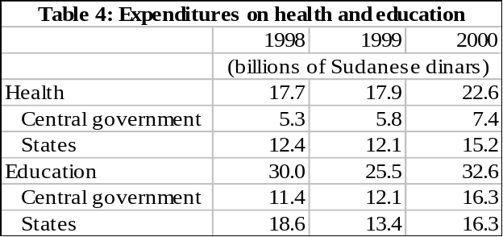
Source: NSSF and Ministry of Finance of Sudan
Moreover, in contrast to the aims of decentralization, and as can be seen from Table 5 and Appendix Figures 1 and 2, since 1998, the proportion of central government total spending in health and education has been gradually increasing vis-à-vis the states’ share (see Appendix: Figure 2). In the health sector, the state government carried out the bulk of current expenditure, whereas the central government concentrated on development or capital expenditure and has been increasing its share in it gradually over time (see Appendix: Figure 3). By contrast, in the education sector development expenditure appears to be equally split between the state and central government, and whereas in 1998, the state share was higher in current expenditure, the central government has gradually increased its share so it currently equals the state share (see Appendix: Figure 4). In sum, fiscal decentralization has so far only been coupled with a gradual shift of current health expenditure to the state level, whereas current education expenditure remains equally split between the state and central governments. This trend may be influenced by the fact that several states have since 1998, been running arrears on teachers’ salaries and the central government had to step in and pay those directly.
Table 5. Sudan: Share of State and Central Expenditure on Health and Education
 |  |  |  | 1998 | 1999 | 2000 | 2001
 |  | (In percent of total expenditure on sub-category)
Health
Central government |  | 29.9% |  |  | 32.4% | 32.7% | ...
Current expenditures |  | 28.2% |  |  | 29.3% | 27.6% | ...
Development expenditures |  | 71.4% |  |  | 66.7% | 78.3% | 85.7%
States |  |  | 70.1% |  | 67.6% | 67.3% | ...
Current expenditures |  | 71.8% |  |  | 70.7% | 72.4% | ...
Development expenditures |  | 28.6% |  |  | 33.3% | 21.7% | 14.3%
Education
Central government |  | 38.0% |  |  | 47.5% | 50.0% | ...
Current expenditures |  | 37.9% |  |  | 47.4% | 50.0% | ...
Development expenditures |  | 50.0% |  |  | 50.0% | 50.0% | 50.0%
States |  | 62.0% |  |  | 52.5% | 50.0% | ...
Current expenditures |  | 62.1% |  |  | 52.6% | 50.0% | ...
Development expenditures |  | 50.0% |  |  | 50.0% | 50.0% | 50.0%
Source: NSSF and Ministry of Finance of Sudan.

However, looking at total public expenditure (combining both state and central outlays) on health and education, it is quite clear that Sudan spends a very small proportion of its GDP on these two sectors. Overall, total public spending on health is about 0.7 percent of GDP, while total public education is around 1.0 percent of GDP (see Table 6). Although there have been some shifts in expenditure assignments between the state and central government, yet the share of total social spending to GDP appears to have been constant since the adoption of fiscal Federalism.
In particular, Sudan’s performance compares poorly to its neighboring countries. As can be seen from Table 7, the shares of public spending on health and education, when measured against both GDP and total government spending, are found to be extremely low compared to the regional averages of both African and Middle Eastern Countries. An argument can be made, therefore, for increasing the amount of public resources devoted to the social sector in Sudan, particularly in light of low and slowly progressing social indicators.
Table 6. Sudan: Expenditures on health and education in Percent of GDP
 |  | 1998 | 1999 | 2000
Total
Health |  | 0.8 | 0.7 | 0.8
Education |  | 1.3 | 1.0 | 1.2
Central Government
Health |  | 0.2 | 0.2 | 0.3
Education |  | 0.5 | 0.5 | 0.6
Source: NSSF and Ministry of Finance of Sudan.

Table 7: Public Spending on Health and Education in Sudan and Other Developing Countries, 1999
Country | Spending on Education |  | Spending on Health |  | Total Spending on Education and Health
 | as percent of Total government spending | as percent of GDP | as percent of Total government Spending | as percent of GDP | as percent of Total government Spending | as percent of GDP
Sudan | 8.6 | 1.0 | 6.0 | 0.7 | 14.6 | 1.7
Developing countries
Africa | 14.9 | 4.6 | 7.0 | 2.3 | 21.9 | 6.9
Asia | 16.5 | 4.7 | 7.8 | 2.4 | 24.4 | 7.1
M. East and N. Africa | 15.6 | 4.8 | 5.5 | 1.7 | 21.1 | 6.5
Latin America | 16.5 | 4.3 | 10.0 | 2.7 | 26.6 | 7.0
Europe | 12.7 | 4.5 | 8.6 | 3.3 | 21.3 | 7.8
Average | 15.3 | 4.6 | 7.8 | 2.5 | 23.1 | 7.1
Source: Calculated from database on” Education and Health Spending", Fiscal Affairs Department, IMF.

Finally, it is worth examining the distribution of sub-national expenditure by sector and state. Table 8 shows the pattern across the three main social spending sectors: water, health and education. In 2001, state social expenditure hovered around 9 percent of GDP, and was more or less equally divided between the water, health and education sectors. When comparing expenditures between the states, Appendix Table A3 shows that the high revenue raising capacity of rich states such as Khartoum, Red sea and Al-Jazeerah allows them to spend a proportionally higher share of total state spending on water and education. ^{[2]} While some states with higher poverty rates and lower education attainment indicators such as North Kurdufan and the Southern states also tend to spend a relatively higher amount than the average of other states. Expenditure levels on health appear to be more or less equalized across states, with only Gadaref spending a slightly higher amount than the rest of the states.
Table 8. State Expenditure by Sector (2001)
 | Water | Health | Education | Total
Total Expenditure (bn of SD) | 984.4 | 913.0 | 910.9 | 2,808.3
% of Total | 35.1% | 32.5% | 32.4% | 100.0%
% of GDP | 3.1% | 2.9% | 2.9% | 9.0%

Social Service Provision
The above analysis indicates the generally low levels of public spending devoted to social services in Sudan. This amount has been slowly rising since 1995, but the available evidence also shows that an increasing share of state spending on health, but not education has accompanied decentralization. In what follows, we attempt to examine the impact of this changing pattern of spending on actual outcomes in the social sector. In order to demonstrate time/regional patterns of poverty and social indicators, we use basic statistical analysis applied to data collected in the Multiple Indicator Cluster Surveys (MICS) of 1995 and 2000. For more detailed social indicators, we also examine the Safe Motherhood Survey (1999) published by the Federal Ministry of Health, the Central Bureau of Statistics, and the United Nations Population Fund.
Although recent surveys show improvements in some indicators such as mortality, nutrition and literacy rates, they also point to deterioration in a number of other crucial social indicators, and in regional disparities in service delivery. The Multiple Indicator Cluster Survey (MICS) and Safe Motherhood Survey (SMS), both conducted in 1999, show that 43 percent of the adult population are illiterate, 30 percent of the population have no access to health services, 40 percent have no access to safe water, and 60 percent have no access to sanitary services. Compared to the early 1990s, there were some modest improvements in infant mortality rates, malnutrition, adult literacy rates and access to safe water. At the same time, however, there was a marked deterioration in primary school enrolment, child immunization and incidence of infectious diseases (see Appendix: Table A4). The problem of significant regional disparities also persists. For example, school enrolment ratio is as high as 78 percent in Khartoum state, while it is only 26 percent in South Darfour, and ranges from 9-18 percent in the Southern states (see Appendix: Figure 5).

As argued in this paper one area to determine whether decentralization has led to progress in poverty reduction in Sudan, is to examine whether regional differences in social indicators have been reduced. Table A5 provides a snapshot of these indicators based on the MICS 2000 results. ^{[3]} The figures clearly show that regional disparities persist in both education and health indicators. In education, the highest adult literacy rates and primary school enrollment ratios are still in Khartoum, Al-Gizera, Northern and River Nile states, whereas the lowest are in Darfur and Kurdufan states. In health, the lowest infant mortality rates, lowest incidence of under five malnutrition and highest level of protection from AIDS are also in these rich states although some states such as North Kordufan and White Nile fare well in some indicators.

Lessons from Selected cases in East Africa: Ethiopia and Uganda
Since the early 1980s many African countries have started a process of transferring both power and resources to their sub national governments. It is seen as a mean for restoring democracy and involving the population in the decision-making process. Some countries, like Ethiopia and Uganda, have moved fast. In this section, we will briefly review the state of fiscal decentralization in two countries, with the aim of drawing lessons for Sudan.

Ethiopia
The process of fiscal decentralization was initiated in Ethiopia in 1992. It was kick started mainly because of famine, the ethnically diverse regions and the succession of Eritrea. Providing local governments with additional autonomy was widely seen as a way to unite the ethnically fragmented country together, in addition to delegating them the task of solving their own economic problems. However, until 1999 the regions remained financially dependent on the federal government for about 70 percent of their expenditures. The central government had scarce resources to spend on health, education and other social services during the early 1990s. In 1990, the authorities spent 2.5 percent and 0.8 percent of GDP on education and health respectively. These ratios have gradually increased over the years, and respectively reached 3.3 percent 1.1 percent of GDP in 1999 (Table 9)

Table 9: Ethiopia -- Spending on Education and Health, 1990-1999
(as a percent of GDP)
 | 1990 | 1991 | 1992 | 1993 | 1994 | 1995 | 1996 | 1997 | 1998 | 1999
Education | 2.5 | 2.5 | 2.8 | 3.5 | 3.3 | 3.6 | 3.5 | 3.5 | 3.6 | 3.3
Health | 0.8 | 0.9 | 1.0 | 1.2 | 1.3 | 1.3 | 1.4 | 1.6 | 1.6 | 1.1
Total | 3.3 | 3.4 | 3.8 | 4.8 | 4.6 | 4.9 | 5.0 | 5.2 | 5.2 | 4.4

Three important factors have helped Ethiopia improve its social services. First, it has developed a fairly robust and extensive framework to support decentralization. Second, it has recognized the importance of capacity building at the sub-national level. And finally, the authorities have developed an important significant intergovernmental transfer program. Recent studies highlight that the pressing remaining issues include: the necessity of implementing the sense of ownership at the local level, and helping local government improve their own sources of revenue, which have so far been relying heavily on grants.

Uganda
Fiscal decentralization was gradually implemented in Uganda since 1993, and like in South Africa, it has served as an avenue for national unity. Prior to decentralization, the central government played a major role in providing funds for health and education related expenditures. After decentralization, local governments became the recipient of these funds and took charge of providing those services to the local population.

Overall, since the implementation of fiscal decentralization in 1993, poverty appears to have fallen markedly in Uganda. According to a poverty line approach, the proportion of Ugandans living in poverty fell from 55.5 percent in 1992 to about 44.0 percent in 1997. This has also been reflected in regional poverty, which has seen a decline as well (Table 10). The improvement in poverty is reflected by the policies implemented by the authorities in recent years, and which have heavily focused on education and healthcare, in addition to some other socially related sectors such as agriculture and water. This interest has been evidenced by the increase in education and health related expenditures. In 1990, the authorities spent 1.3 percent and 0.4 percent of GDP on education and health respectively. These ratios have gradually increased over the years, and reached 2.9 percent and 2.4 percent of GDP respectively in 1999 (Table 11).

Table 10. Poverty in Uganda, 1992/1993 – 1996/1997
(percentage of the population living below the poverty line)
 | 1992/1993 | 1996/1997
Total | 55.5 | 44.0
Urban | 28.2 | 16.3
Rural | 59.4 | 48.2

Table 11: Uganda - Spending on Education and Health, 1990-1999
(as a percent of GDP)
 | 1990 | 1991 | 1992 | 1993 | 1994 | 1995 | 1996 | 1997 | 1998 | 1999
Education | 1.3 | 0.5 | 1.3 | 1.2 | 2.3 | 2.1 | 2.8 | 2.9 | 4.3 | 3.8
Health | 0.4 | 0.2 | 0.5 | 0.5 | 0.9 | 1.0 | 0.8 | 2.4 | 2.4 | 2.2
Total | 1.7 | 0.7 | 1.8 | 1.7 | 3.2 | 3.1 | 3.6 | 5.3 | 6.7 | 5.9

Overall, decentralization has improved the services provided to the poor in addition to encouraging a higher degree of involvement at the local level. In particular, recent reports suggest that the efficiency of the police force and the civil servants have improved. Among the problems still encountered are: the inability of locally generating revenues, the inexperience of local officials, and poor accountability, and lack of transparency.

Conclusion
The available evidence indicates that so far decentralization has not led to a substantial improvement in social service delivery in Sudan. Some important indicators such as infant mortality, malnutrition and adult illiteracy rate that enter in the calculation of the human development index have improved over this period, yet other crucial indicators have either stagnated or even deteriorated. Most alarming is the apparent deterioration in the primary school enrolment, child immunization and incidence of infectious diseases. Analysis of the evolution in budgetary outlays on education, health and water indicate that after more than five years of fiscal decentralization, total spending on the social sectors is still very low in Sudan and there is only evidence of decentralization of spending on health, but not education. In addition to a shortage in funding, the effectiveness of decentralization in Sudan is likely be reduced by lack of managerial expertise at the sub-national levels.

It is worth noting, however, that weak social indicators cannot be solely attributed to fiscal decentralization in Sudan. The whole process needs to be evaluated within the wider macro-economic developments in the country. Since 1996, a fiscal constraint has been re-instated in Sudan, which succeeded in restoring macro economic stability and putting an end to hyperinflation. Surely this has been a decisive development that positively impacted, at least urban poverty. However, the low service delivery at the state and local levels appears to be related first and foremost to the fact that Sudan is still a conflict country. Additional factors that contributed to the deterioration of the social indicators are the presence of a weak capacity building, the inability to mobilize revenue and direct them towards improving social conditions. Furthermore, Sudan was virtually unable to have access to foreign aid since the early 1990s, especially when compared to other East African countries such as Ethiopia and Uganda, ^{[4]} who benefited from HIPC debt relief and other forms of international support.

So what ought to be done to improve this situation? The clear lessons to be drawn from examples of relatively successful decentralization in Ethiopia and Uganda, are several. First, in addition to assigning expenditure and revenue responsibilities among the different levels of government, the fiscal decentralization process should ensure that sub national policymaking autonomy also exits and there should be clarity in the roles and responsibilities between the central and the local governments. Second, harmonizing of tax policies between the states is a priority in order to prevent competitive behavior amongst them, which ultimately reduces revenue mobilization. Finally, authorities should ensure that capacity building and strengthening of state finances are part of the process. In this regard, the international community has a clear role to play, at least through the provision of much needed technical assistance at the state and local levels.

Endnotes
[1] The views expressed in this paper are those of the authors and do not necessarily represent those of the International Monetary Fund.
[2] Data on expenditure on water is not available
[3] Although the final results for another Multiple Indicator Cluster Survey are available for 1995, differences in the sampling methodology (including number of states covered) and definition of indicators do not allow for a simple comparison. In future drafts of the paper, we will attempt to derive from the MICS 2000 results a comparable sub-sample, to examine changes over time in some health and education indicators.
[4] Ethiopia reached its decision point under the Enhanced HIPC initiative in November 2001. Uganda has benefited from debt relief both under the original and enhanced HIPC initiatives, in 1998 and 2000 respectively.

References

Bardhan, Pranab, and Mookherjee, Dilip, 2000, “Decentralized Anti-Poverty Program
Delivery in Developing Countries,” mimeo.

Bardhan, Pranab, and Mookherjee, Dilip, 2001, “Corruption and Decentralization of
Infrastructure Delivery in Developing Countries,” unpublished manuscript.

Blanchard, Olivier, and Shleifer, Andrei (2001), Federalism With and Without Political
Centralization: China Versus Russia, IMF Staff Papers, Vol. 48, pp. 171 – 179.

Brosio, Giorgio, 2000, “Decentralization in Africa,” paper prepared for the IMF conference
on Fiscal Decentralization, Washington D.C., November 2000.

Dabla-Norris, Era and Weber, Shlomo, 2001, “Regional Disparities and Transfer Policies in
Russia: Theory and Evidence,” IMF Working Paper WP/01/199.

International Monetary Fund, 2001, Sudan-Recent Economic Developments.

Robalino, David; Picazo, Oscar, and Voetberg, Albertus (2001), “Does Fiscal
Decentralization Improve Health Outcomes? Evidence from a Cross Country
Analysis,” World Bank Policy Research Paper No. 2565.

Tanzi, Vito, 2000, On Fiscal Federalism: Issues to Worry About,” paper prepared for the
IMF conference on Fiscal Decentralization, Washington D.C., November 2000.

Von Braun, Joachim, and Grote, Ulrike, 2000, “Does Decentralization Serve the Poor?”
Paper prepared for the IMF conference on Fiscal Decentralization, Washington D.C.,
November 2000.

Winkler, Donald (1989), “Decentralization in Education: An Economic Perspective,”
Working Paper No. 143.

Appendix

Table A1: Sudan -- Comparison of Social Welfare Indicators
 | Population | Per Capita | Life | Infant Mortality | Adult | Primary Gross | Labor Force | Population with Access to Social Infrastructure
 |  | GNP | Expectancy | Rate, per 1000 | Illiteracy | Enrollment Ratios | Participation | Sanitation | Safe water | Health Services
 | millions | US$ | (years) | (percent) | (percent ) | (percent) | (percent) | (percent) | (percent) | (percent)
 | 1999 | 1998 | 1998 | 1998 | 1998 | 1996 | 1994 | 1994/95
Eritrea | 3.7 | 200 | 52 | 86 | … | 54 | … | 13 | 22 | …
Ethiopia | 61.1 | 100 | 44 | 108 | 64 | 43 | 42.8 | 19 | 27 | 46
Kenya | 29.5 | 350 | 50 | 64 | 20 | 84 | 49.7 | 77 | 49 | 77
Sudan | 28.9 | 290 | 56 | 67 | 45 | 53 | 36.8 | 22 | 50 | 70
Tanzania | 32.8 | 210 | 48 | 78 | 27 | 66 | 51.3 | 86 | 49 | 42
Uganda | 21.1 | 310 | 43 | 99 | 35 | 74 | 54.8 | 60 | 42 | 49
Sources: African Development Bank and World Bank.

Table A2. Sudan: Expenditures on health and education
 |  | 1998 | 1999 | 2000 | 2001
 |  | (billions of Sudanese dinars)
Health
Central government |  | 5.3 | 5.8 | 7.4 | 11.7
Current expenditures |  | 4.8 | 4.8 | 5.6 | 9.3
Development expenditures |  | 0.5 | 1.0 | 1.8 | 2.4
States |  | 12.4 | 12.1 | 15.2 | ...
Current expenditures |  | 12.2 | 11.6 | 14.7 | ...
Development expenditures |  | 0.2 | 0.5 | 0.5 | 0.4
Total |  | 17.7 | 17.9 | 22.6 | ...
Current expenditures |  | 17.0 | 16.4 | 20.3 | ...
Development expenditures |  | 0.7 | 1.5 | 2.3 | 2.8
Education
Central government |  | 11.4 | 12.1 | 16.3 | 24.1
Current expenditures |  | 11.3 | 11.9 | 15.9 | 22.9
Development expenditures |  | 0.1 | 0.2 | 0.4 | 1.2
States |  | 18.6 | 13.4 | 16.3 | ...
Current expenditures |  | 18.5 | 13.2 | 15.9 | ...
Development expenditures |  | 0.1 | 0.2 | 0.4 | 1.2
Total |  | 30.0 | 25.5 | 32.6 | ...
Current expenditures |  | 29.8 | 25.1 | 31.8 | ...
Development expenditures |  | 0.2 | 0.4 | 0.8 | 2.4
Source: NSSF and Ministry of Finance of Sudan.

Table A3. State Expenditure by Sector (2001)
(in millions of Sudanese Dinars)
 |  | Water |  | Health |  | Education |  | Total Social Expenditure
 |  |  | % of Total |  | % of Total |  | % of Total |  | % of Total
Nile River |  | 57.0 | 5.8% | 52.0 | 5.7% | 38.4 | 4.2% | 147.5 | 5.2%
North Darfour |  | 41.8 | 4.2% | 53.0 | 5.8% | 67.1 | 7.4% | 162.0 | 5.8%
Northern |  | 81.7 | 8.3% | 57.0 | 6.2% | 23.5 | 2.6% | 162.3 | 5.8%
Red Sea |  | 111.0 | 11.3% | 50.0 | 5.5% | 5.0 | 0.5% | 166.2 | 5.9%
Blue Nile |  | 44.0 | 4.5% | 57.0 | 6.2% | 58.3 | 6.4% | 159.4 | 5.7%
Kassala |  | 33.0 | 3.4% | 52.0 | 5.7% | 21.2 | 2.3% | 106.3 | 3.8%
Khartoum |  | - | - | 50.0 | 5.5% | 82.5 | 9.1% | 132.6 | 4.7%
Sennar |  | 99.5 | 10.1% | 55.0 | 6.0% | 37.8 | 4.1% | 192.5 | 6.8%
Al-Jazeerah |  | 160.0 | 16.3% | 50.0 | 5.5% | 130.4 | 14.3% | 340.6 | 12.1%
South Darfour |  | 81.7 | 8.3% | 57.0 | 6.2% | 53.4 | 5.9% | 192.2 | 6.8%
West Darfour |  | 24.7 | 2.5% | 52.0 | 5.7% | 19.4 | 2.1% | 96.2 | 3.4%
Gadaref |  | 77.6 | 7.9% | 65.0 | 7.1% | 40.8 | 4.5% | 183.6 | 6.5%
North Kurdufan |  | 35.8 | 3.6% | 55.0 | 6.0% | 84.7 | 9.3% | 175.6 | 6.2%
South Kurdufan |  | 64.0 | 6.5% | 55.0 | 6.0% | 26.9 | 3.0% | 146.0 | 5.2%
West Kurdufan |  | 38.6 | 3.9% | 50.0 | 5.5% | 54.9 | 6.0% | 143.6 | 5.1%
White Nile |  | 34.0 | 3.5% | 53.0 | 5.8% | 62.8 | 6.9% | 149.9 | 5.3%
Southern states |  | - | - | 50.0 | 5.5% | 92.0 | 10.1% | 142.1 | 5.1%
Reserves |  | - | - | - | - | 11.8 | 1.3% | 11.8 | 0.4%
Simple Average |  | 57.9 | 5.9% | 53.7 | 5.9% | 52.9 | 5.8% | 164.6 | 5.9%
TOTAL |  | 984.4 | 100.0% | 913.0 | 100.0% | 910.9 | 100.0% | 2,810.3 | 100.0%
Source: NSSF and Ministry of Finance of Sudan.

Table A4: Sudan --End-Decade Goals on Social Indicators
 |  | Decade Data |  |  | Goal | Reach
Global Goals | Indicators | 1990-93 | 1995 | 2000 | 2000 | Goal
Mortality Rates
Reduce by 1/3 or to 70/1000 births | Infant Mortality Rate-Total | 145.0 |  | 132.0 | 90.0 | C
Reduce by 1/3 or to 50/1000 births | Under-five Mortality Rate-Total | 108.0 |  | 82.0 | 425.0 | C
Reduce by 1/2 | Maternal Mortality Ratio (MMR)/1000,000 | 550.0 |  | 509.0 | 325.0 | D
Malnutrition
Reduce by 1/2 | % of under 5's with moderate and severe underweight | 30.0 |  | 22.6 | 10.0 | C
Access to Safe Water
100% | % of population with access to safe water ( total) | 50.0 |  | 59.5 | 100.0 | D
100% | % of population with access to safe water ( urban) | 60.0 |  | 79.0 | 100.0 | D
100% | % of population with access to safe water ( rural) | 20.0 |  | 59.7 | 100.0 | D
Primary School Enrolment Ratio
100% | Primary School Enrolment Ratio-gross (total) | 73.5 |  | 48.0 | 100.0 | E
100% | Primary School Enrolment Ratio-gross (male) | 57.3 |  | 42.0 | 100.0 | E
100% | Primary School Enrolment Ratio-gross (female) | 65.6 |  | 46.0 | 100.0 | E
Adult Literacy Rates
Reduce by Illiteracy by 1/2, with special attention to females | Adult Literacy Rate (total) |  | 50.8 | 57.2 | 100.0 | C
 | Adult Literacy Rate (male) |  | 63.5 | 67.2 | 100.0 | C
 | Adult Literacy Rate (female) |  | 38.3 | 47.1 | 100.0 | C
 | Adult Literacy Rate (female/male) |  | 61.0 | 70.0 | 100.0 | C
Reduction of Infectious Diseases
To zero | Annual number of Polio cases |  | 51.0 | 56.0 | 0.0 | E
To zero | Annual number of neo-natal Tetanus cases |  | 53.0 | 88.0 | 0.0 | E
Reduce by 95 % | Annual under-five deaths from Measles |  | 405.0 | 2875.0 | 95.0 | E
Immunization Rates
90% | % of 1 year olds fully Immunized -DPT | 88.0 |  | 65.4 | 90.0 | E
90% | % of 1 year olds fully Immunized -Measles | 74.0 |  | 60.5 | 95.0 | E
90% | % of 1 year olds fully Immunized -Polio | 77.0 |  | 65.4 | 100.0 | E
90% | % of 1 year olds fully Immunized -BCG (TB) | 76.0 |  | 64.0 | 90.0 | E
Source: National Council for Child Welfare, Sudan Ministry of Social welfare (2000) "Sudan- End Decade Report". Based on data from Population Census 1993, Multiple Indicator Cluster Surveys 1995 and 2000 and Safe Motherhood Surveys, 1993 and 1999
Note: A - Reached Goal, B - almost reached Goal, C- progres, D- little/no progress, E - worse

Table A5: Education and Health Indicators Across Northern States, 2000
 |  | Primary school enrollments
 | Percentage of Population 15 years and older that is literate | Total | Males | Females | Infant Mortality Rate | Under Five Malnutrition (Weight for Height below 2SD) | Protection from AIDS 1/
Northern | 71.5 | 65.9 | 65.1 | 66.8 | 56.0 | 13.4 | 33.7
River Nile | 71.7 | 71.6 | 71.7 | 71.6 | 57.0 | 16.4 | 39.5
Red Sea | 52.0 | 49.0 | 47.3 | 50.9 | 116.0 | 10.7 | 20.1
Kassala | 38.0 | 47.2 | 46.6 | 47.8 | 101.0 | 5.7 | 16.5
al-Gadarif | 43.3 | 45.4 | 47.7 | 42.8 | 67.0 | 10.8 | 17.2
Al-Gazira | 58.6 | 57.1 | 56.6 | 57.5 | 43.0 | 13.5 | 36.3
Sinnar | 50.0 | 45.8 | 45.4 | 46.1 | 51.0 | 11.0 | 24.2
White Nile | 51.6 | 54.9 | 55.8 | 54.1 | 70.0 | 15.5 | 39.9
Blue Nile | 36.7 | 38.9 | 41.4 | 36.3 | 101.0 | 10.1 | 15.7
Khartoum | 74.9 | 69.7 | 71.1 | 68.4 | 69.0 | 11.8 | 49.3
Northern Kordufan | 40.2 | 35.1 | 37.7 | 32.4 | 60.0 | 16.5 | 22.2
Southern Kordufan | 35.2 | 36.2 | 36.1 | 36.3 | 95.0 | 8.1 | 19.2
Western Kordufan | 34.4 | 39.7 | 42.8 | 36.6 | 72.0 | 11.3 | 12.7
Northern Darfur | 48.1 | 48.9 | 51.7 | 46.3 | 61.0 | 15.1 | 14.7
Southern Darfur | 40.7 | 21.6 | 24.1 | 19.3 | 64.0 | 8.5 | 25.3
Western Darfur | 25.9 | 27.0 | 29.7 | 24.5 | 71.0 | 4.6 | 11.9
Total Northern Sudan | 49.9 | 46.8 | 48.0 | 45.6 | 68.0 | 11.2 | 24.8
Source: Multiple Indicator Cluster Surveys, 2000.
1/ Percentage of women who know how at least one way how to protect themselves from AIDS.

FIGURES

Figure 1. Sudan: Health and education Expenditures, 1998 - 2000

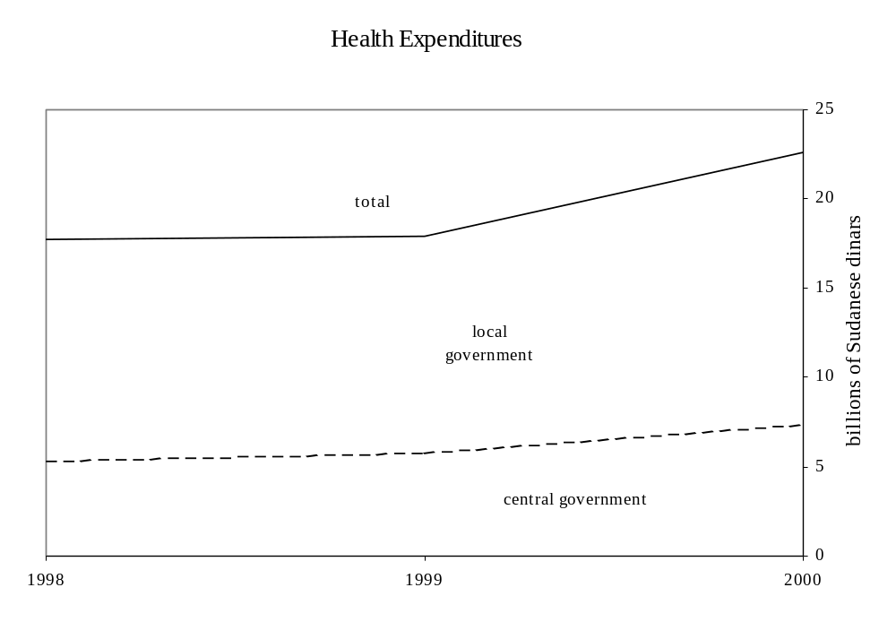

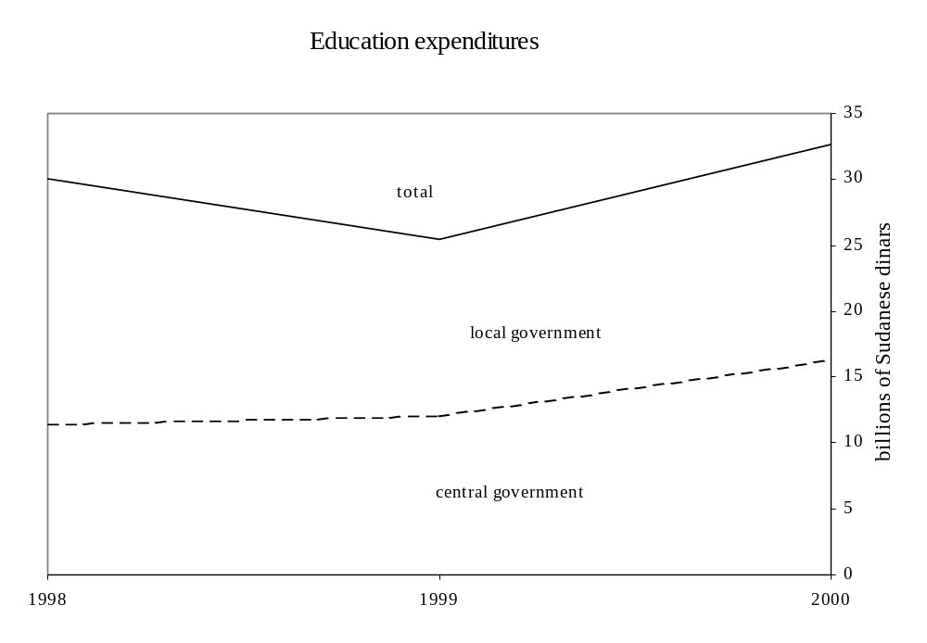

Source: World Bank database.

Figure 2. Sudan: Expenditures on Health and Education, 1998 - 2000

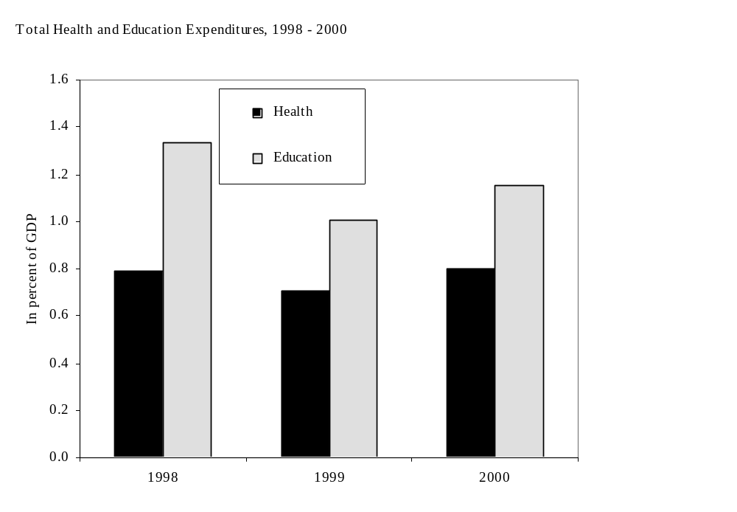

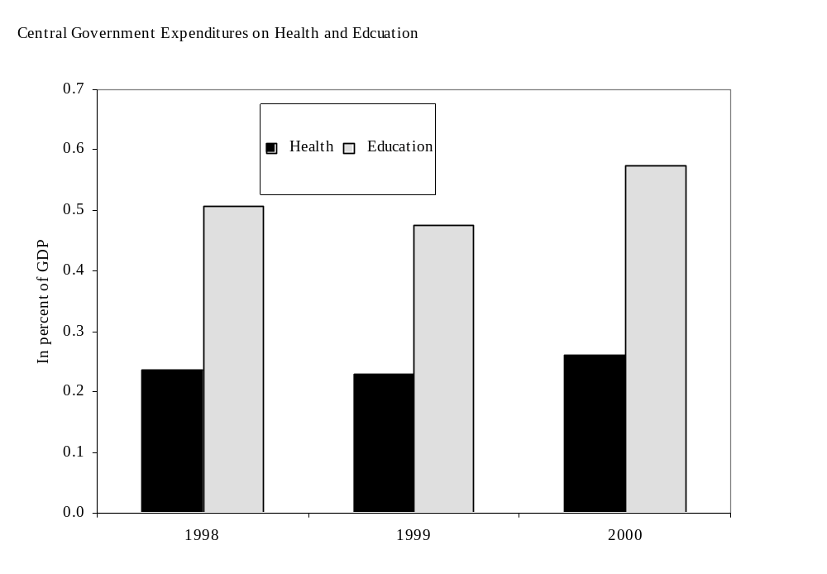
Source: World Bank database.

Figure 3. Sudan: Expenditures on Health, 1998 - 2001

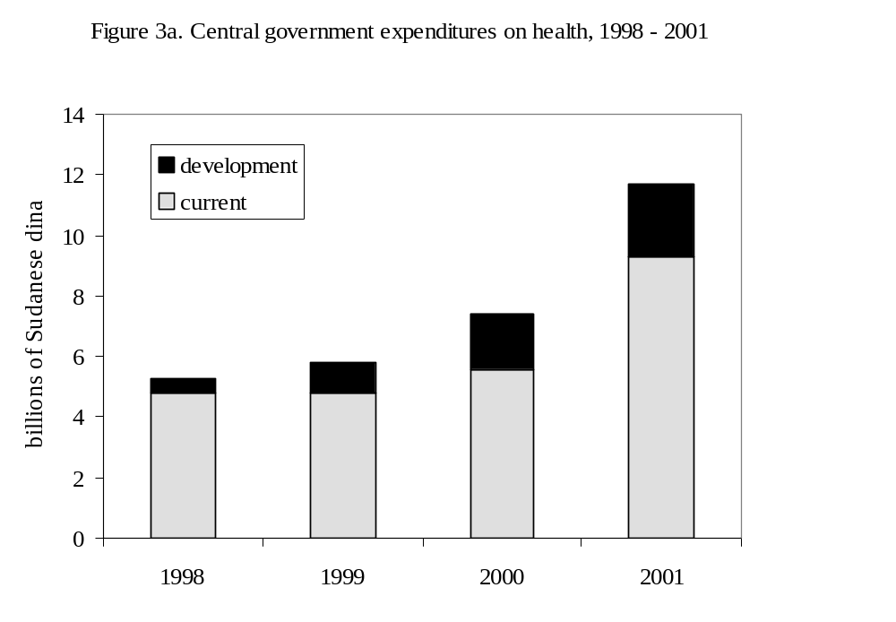

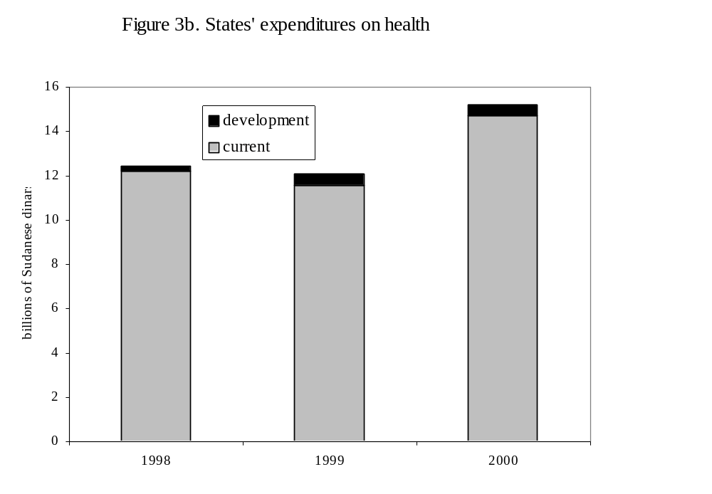
Source: World Bank database.

Figure 4. Sudan: Expenditures on Education, 1998 - 2001

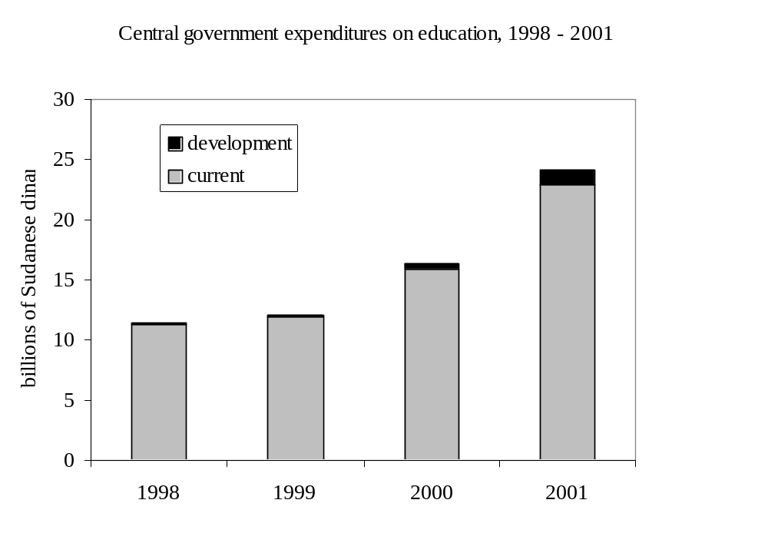

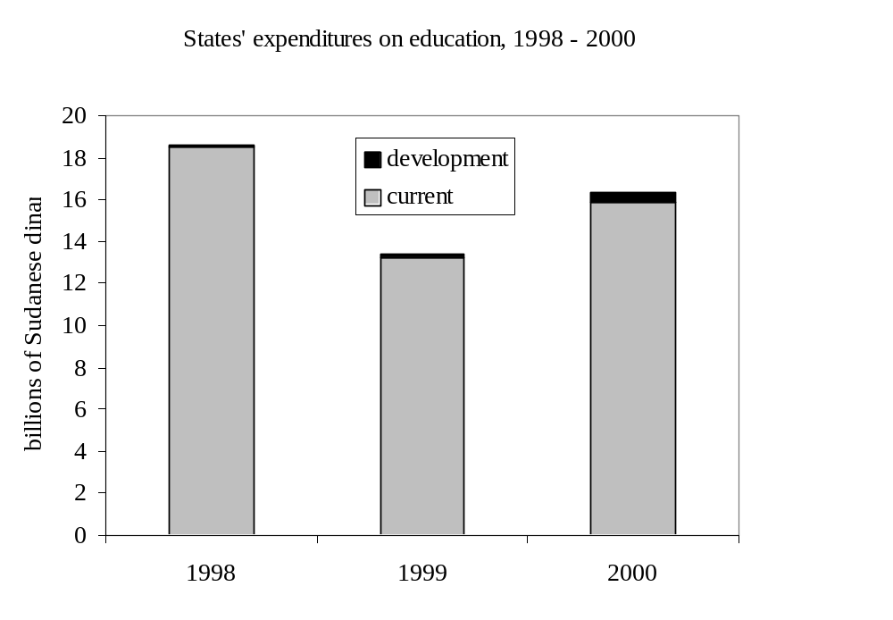
Source: World Bank database.



